ADDRESSING TYPOGRAPHIC HALLUCINATION IN GENERATIVE AI IMAGES: AN OPEN-SET METRIC LEARNING APPROACH TO FONT STYLE RECOGNITION

A Thesis Proposal
Presented to the Faculty of the
Department of Computer, Information Sciences and Mathematics
University of San Carlos

In Partial Fulfillment
of the Requirements for the Degree
BACHELOR OF SCIENCE IN COMPUTER SCIENCE

By
MATT ERRON G. CABARRUBIAS
JANRITCH D. DIPUTADO

CHRISTINE D. BANDALAN, MEng
Faculty Adviser

July 2026

Abstract
Generative AI image tools such as Gemini, GPT Image, and Midjourney now produce finished graphics with rendered text, yet they render that text through probabilistic glyph deformation (micro-warping of strokes, distorted spacing, and merged or invented letterforms), a failure this study terms typographic hallucination. When a designer wants to reuse such typography, the first step is to name the font, and it is exactly this step that current tools break on. Established font recognition assumes a geometrically intact glyph, so classifiers trained on pristine specimens overfit and collapse in the wild; commercial identifiers add a further cost, mapping shapes to paid licenses, and none can abstain when a glyph belongs to no catalogued face. This study proposes an open-set metric-learning framework that maps a hallucinated text crop to a ranked shortlist of the closest fonts in a localized palette of the top 50 to 100 open-source Google Fonts, or to an “unknown” verdict when no palette font applies, enabling free, license-clear typographic reconstruction. A synthetic data pipeline renders clean word crops and degrades them with controlled operators (elastic warp, blur and noise, and kerning jitter) to reproduce documented generative deformation. A metric embedding built on a frozen self-supervised Vision Transformer separates typographic identity from deformation, and a post-hoc rejection score handles the open-set case. Evaluation combines Top-K accuracy, a re-render-and-compare structural-similarity distance, a confusion matrix organized by typographic family, and a three-person human-proxy panel on real generative crops. The framework is expected to contribute a deformation-robust, license-clear approach to open-set font recognition; empirical results are deferred until training and evaluation runs complete.
Keywords: typographic hallucination; font style recognition; metric learning; open-set recognition; generative AI

Chapter 1: Introduction

1.1 Introduction
Typography is a deliberate design decision. The typeface on a poster, a product mockup, or a social media graphic carries brand identity and tone as much as the words themselves, and a designer who selects a face is choosing a specific, nameable artifact from a catalogue of thousands. Generative AI image tools now enter this workflow directly: systems such as Google’s Gemini “Nano Banana”, OpenAI’s GPT Image, and Midjourney produce finished graphics complete with rendered text in seconds. When a designer wants to adopt or extend the typography of such an image, the first task is to name the font. That single step is where the current generation of tools breaks down.
Three concepts frame the solution this study pursues. The first is the problem itself. This study uses typographic hallucination to name the probabilistic glyph deformation that generative models introduce when rendering text: micro-warping of strokes, distorted spacing, and merged or invented letterforms. The second is open-set recognition, the requirement that a recognizer rank the closest known fonts and also return an “unknown” verdict when the glyph belongs to no font in its catalogue, as a hallucinated crop often will. The third is metric learning: rather than training a fixed classifier over a closed list of fonts, the model learns an embedding in which geometric distance encodes typographic similarity, so that a deformed crop lands near its source font. This chapter introduces these concepts only as far as the problem requires, deferring their technical treatment to Chapter 3.

1.2 Background of the Study
Typographic hallucination is a structured failure, not random noise. Generative models render text unreliably because they treat a character string as a semantic token rather than a set of glyphs under sub-character spatial control; uncorrected renderings from a system like Stable Diffusion XL are typographically accurate in fewer than 20% of cases on a design benchmark (Liu et al., 2024). During denoising a character’s attention map smears into its neighbors, warping strokes and destabilizing spacing (Gillani et al., 2025), and because diffusion models encode style as a position on a continuous latent manifold rather than a discrete list of named faces, they emit intermediate glyphs that correspond to no real typeface (Kondo et al., 2024). The distortion is worst on the rare and display letterforms in the long tail of usage (Zhuang et al., 2025), precisely the expressive faces a designer is most likely to have chosen.
Font recognition as a field was never built for this input. The classical paradigm, exemplified by DeepFont, learns from clean synthetic specimens and assumes every input contains a geometrically intact glyph to recover (Wang et al., 2015); traditional optical character recognition reaches roughly 98% accuracy on standard document scans for the same reason (Ponnuru et al., 2024). A hallucinated crop violates that assumption, because its signal and its noise are produced together by one generative process. Enlarging the reference catalogue does not resolve the problem: the largest open classifier covers 3,474 Google Fonts yet still overfits pristine glyphs (Jiang et al., 2025), and even a modern frozen Vision Transformer baseline collapses to 40.2% family-level accuracy on non-synthetic input by its authors’ own report (Chen et al., 2026). General-purpose vision-language models fare no better, as the lexical meaning of the rendered word overrides their reading of its visual form (Li, Song, et al., 2025).

1.3 Statement of the Problem
As the Background established, generative typography arrives probabilistically deformed, while the tools that would name its font assume a geometrically intact glyph and fail as the catalogue scales. The result is a two-part gap that no existing system closes: none reads font identity from a hallucinated rather than a pristine glyph, and none refuses to answer when the glyph belongs to no catalogued font, the open-set case a hallucinated crop routinely presents (Lu et al., 2025). Free, license-clear reconstruction of generative typography therefore has no working tool, and designers are pushed back toward paid identifiers that fail on the very inputs at issue.

1.4 Objectives of the Study

1.4.1 General Objective
The general objective of this study is to design, build, and evaluate an open-set metric-learning system that identifies the typeface of hallucinated text in generative-AI images, mapping a deformed text crop to a ranked shortlist of the closest fonts in a localized palette of the top 50 to 100 Google Fonts, or to an “unknown” verdict when no palette font applies.

1.4.2 Specific Objectives
Specifically, the study aims to:
- Curate the localized open-set font palette, and build a synthetic data pipeline that renders pristine word crops and degrades them with a controlled operator (elastic warp, blur and noise, and kerning jitter) that reproduces documented generative deformation (Gillani et al., 2025; Kondo et al., 2024).
- Train a deformation-robust metric embedding on a frozen, register-corrected DINOv2 backbone (Oquab et al., 2024), so that geometric distance in the embedding encodes typographic similarity rather than deformation artifacts.
- Implement an open-set decision that rejects out-of-palette glyphs through a post-hoc rejection score and produces a calibrated Top-K shortlist over the palette (Lu et al., 2025).
- Verify each prediction with a re-render-and-compare typographic distance that is robust to geometric misalignment (Zhang et al., 2024), and analyze the system’s errors by typographic family and by embedding-distance severity.
- Evaluate the system under the Top-1 and Top-3 accuracy protocol against the Storia-AI and DINOv2-LoRA closed-set baselines (Chen et al., 2026; Jiang et al., 2025) and against a three-person human-proxy consensus panel on real generative crops.
- Deploy the trained model behind a web application, so the system can be tested interactively and in real time on uploaded generative-AI images.

1.5 Research Questions
The gap in Section 1.3 frames the study’s central research question: how can the typeface of hallucinated text in a generative-AI image be identified against a localized, open-source font palette when the glyph is probabilistically deformed and may belong to no font in the palette? It resolves into five specific questions, each tracing to an objective above:
- How can a synthetic dataset reproduce the typographic hallucination of generative models faithfully enough to train a deformation-robust recognizer?
- Can a metric embedding built on a frozen self-supervised Vision Transformer separate typographic identity from deformation, so that a hallucinated crop lands near its source font?
- Can an open-set rejection mechanism reliably route an out-of-palette or hallucinated glyph to an “unknown” verdict instead of forcing a match?
- How accurately does the system rank the correct font in a Top-K shortlist, and how does that accuracy compare against existing closed-set baselines and a human-proxy panel?
- Does the system’s error distribution stay within typographic families, so that its mistakes remain visually close to the correct font?

1.6 Scope and Limitations
This study covers the design, training, and evaluation of an open-set font recognizer for hallucinated text. Its scope includes the localized open-source font palette; a synthetic data pipeline that renders pristine word crops and degrades them with a controlled operator of elastic warp, blur and noise, and kerning jitter; a metric-learning stack built on a frozen DINOv2 Vision Transformer in PyTorch; an open-set decision that can reject out-of-palette glyphs; and evaluation under Top-1 and Top-3 accuracy, a re-render-and-compare typographic distance (SSIM/MSE), a confusion matrix organized by typographic family, and a three-person human-proxy panel. The trained model is deployed behind a web application for interactive testing.
Several boundaries limit the study’s reach. Recognition targets a localized open-source palette rather than the full commercial font space, because the goal is free, license-clear reconstruction rather than mapping to paid licenses; fonts outside this palette are therefore only reachable through the “unknown” verdict, not named. The system recognizes text crops rather than full-page layout or template reconstruction, keeping the research question on font identity rather than document structure. It treats each font as a discrete identity rather than regressing continuous variable-font axes, and it is confined to Latin-script typography, where the target Google Fonts palette and the documented hallucination behavior are best characterized. Finally, training relies on synthetically degraded crops: the controlled operator approximates but cannot fully reproduce the deformation of every generative model, so a residual synthetic-to-real domain gap constrains how far accuracy on synthetic data transfers to text from unseen generators.

1.7 Significance of the Study
For the field of computer science and machine learning, this study contributes an open-set metric-learning approach to deformation-robust font identification. It inverts the prevailing paradigm, which trains closed-set classifiers on pristine glyphs and consequently fails in the wild (Wang et al., 2015; Chen et al., 2026), by learning an embedding that tolerates deformation and can abstain when no catalogued font applies.
For practitioners, meaning designers and everyday users of generative AI tools, the system offers a path to free, license-clear reconstruction of generative typography. It maps a hallucinated crop to open-source Google Fonts rather than to paid commercial licenses, and it works on exactly the deformed inputs on which closed identifiers fail, removing the lock-in those tools impose.
For future researchers, the framework is a building block for deformation-robust recognition beyond fonts. Its combination of a controlled synthetic-degradation pipeline with a post-hoc open-set rejection score is a reusable recipe for any fine-grained recognition task where inputs are probabilistically distorted and the true class may lie outside the training catalogue.

Chapter 2: Review of Related Literature

2.1 Introduction
This chapter reviews the literature defining the scope of this thesis and introduces the components of the proposed solution. The review is organized around the structure of the problem itself. It first establishes the limits of current approaches, describes the phenomenon that undermines them, and then introduces the components needed to resolve these limitations. Five thematic areas trace this progression. Legacy font recognition, OCR/Layout and Closed-Set Vector assumptions reviews visual font recognition, the paradigm this work challenges. Traditional methods including DeepFont, classical OCR, Layout analysis, and attention-based localization rely on a closed-set, rigid-glyph assumption. However, generative AI text violates this assumption. Generative AI typographic hallucinations and diffusion latent mutations details these violations, specifically the micro warping, variable kerning, and cross-character attention smearing that this thesis terms typographic hallucination. Existing generative AI research only studies these deformations to suppress them inside the generator, rather than to recover typeface identity from the deformed output. The next three themes build the proposed recognizer. Logit-space thresholds and open-set rejection scores describe the open-set rejection machinery that labels out of palette crops as “unknown”. Feature disentanglement and Frozen-ViT Metric Embedding details the disentangled frozen-ViT embedding used to calculate the rejection score. Advanced Visual Distance Metrics (SSIM) and Human-Proxy Ground-Truth Alignment introduces the deformation-robust distance metric and calibrated Top-K measurement layer used to validate the pipeline.

2.2 Legacy Font Recognition, OCR/Layout & Closed-Set Vector Assumptions
Visual font recognition as a discipline has been studied for a while now, with traces to Wang, Yang, Jin, Shechtman, Aseem and Huang’s (2015) DeepFont with Adobe Research. It was the first, large-scale deep convolutional system for identifying typefaces from photographic inputs. DeepFont’s innovations were inseparable from the assumptions that were built into it. It trained on a synthetic set of clean typographic specimens generated directly from font files, guaranteeing that the discriminative features the network learned were uncontaminated by rendering artifacts like noise. It learned to read the typeface, relating to its stroke ratios, serif geometry, terminal curvature and ascender-to-x-height proportions. It was evaluated under the Top-1/Top-3 (TopK) accuracy protocol that remains the discipline’s standard. It proved that a network trained on clean glyphs, can generalize real photographic inputs with useful accuracy. However this assumption of clean glyphs means that every input is presumed to contain a glyph which exists at render time, and recognition is the recovery of that “fixed” identity from an environmental degradation channel, such as pictures or documents. We adopt the Top-K protocol from DeepFont because it is the established standard, in a system where there is no clean glyph to recover, because signal and noise co-emerge from the same generative process.
Architectural progress has since raised this paradigm’s accuracy without disturbing its founding assumptions. Chen et al. (2026) swap DeepFont’s convolutional stack for a frozen DINOv2 Vision Transformer adapted through Low-Rank Adaptation (LoRA), training only about 0.2% of the backbone’s parameters, and reach roughly 86% Top-1 accuracy across 394 Google Font variants, the current high-water mark for large-scale font classification. Yet the same assumptions hold: the model trains on pristine synthetic renders, stays strictly closed-set over its 394 classes, and, by the authors’ own report, fails on photographs and heavily styled graphics, its family-level accuracy collapsing to 40.2% between near-identical weight variants a clean-glyph encoder cannot separate at working resolution. Chen et al. therefore establish two things at once: that a frozen-ViT embedding is the field’s current representational substrate, adopted in open-set form in Section 2.5, and that even the strongest modern instantiation of that substrate still inherits DeepFont’s categorical exclusion of the deformed, out-of-palette input this work targets.
The same assumption asserts itself in contemporary OCR and layout systems such as by Ponnuru et al. (2024) report 98% accuracy for a Tesseract-based prescription digitization pipeline under scanning defects, and closed-boundary layout analysis grows stable for bounding regions from coherent glyph interiors (Bhunia et al., 2018). Both systems implicitly compute for the same function, that function is well-posed only when an existing, antecedent glyph exists. It is undefined in this sense where the glyph in the image is not a degraded copy of a vector mastery but the primary output of a system with no access entirely to the intended typeface’s geometry.
Recent shifts in document layout analysis that includes Wang, Lv, et al.’s (2025) TransTab and Sheikh et al.’s (2024) UnSupDLA, have begun replacing rigid geometric priors with attention-based, layout-independent feature extraction, establishing a direct precedent for the unsupervised, frozen-ViT architecture adoption. However, while these new attempts to relax spatial constraints during localization, they leave the morphological assumptions of font identity untouched.
Methodologically, we can draw the theoretical scaffolding from Sarker’s (2021) deep-learning taxonomy to justify a lightweight metric head over a frozen backbone, and Plastropoulos and Tegos’s (2024) framework to license synthetic data augmentation via geometric and typographic degradation. Yet, because the broader literature, stretching from DeepFont’s foundational closed-set baseline (Wang et al., 2015) to the modern frozen-ViT state of the art (Chen et al., 2026) and the attention-driven models above, presumes topologically faithful glyphs or treats distortion merely as an external noise channel. None of these studies actually address whether font identity can be recovered from a glyph whose structural deformation is not noise to be inverted, but an irreducible, probabilistic property of a generative latent model.

2.3 Generative AI Typographic Hallucinations & Diffusion Latent Mutations
AI producing morphologically unreliable text is established by several literature studies. Liu et al. (2024) diagnosed the visual text rendering in Stable Diffusion XL, traces the failure to an architectural limitation: the standard text encoder for AI treats a character sequence as a semantic unit and lacks the sub-character spatial awareness needed for typographically accurate output. This resulted in fewer than 20% of uncorrected SDXL renderings as accurate. The study also proposes their own Glyph-ByT5 correction, which fine-tunes the encoder on glyph-conditioned data, and raises the accuracy to 90%, confirming the failure is architectural rather than fundamental. The fact is that for an uncorrected baseline, deformation is the default output state.
Li, Song, et al. (2025) figured out that state-of-the-art vision-language models (VLMs) are readily derailed by an effect: The “Stroop-type” semantic inference, in which the lexical meaning of the rendered word overrides the model’s reading of the visual typeface. Because this effect operates even on clean, legible text, semantic distraction and glyph deformation are independently sufficient to defeat general-purpose recognition. We close off off-the-shelf VLMs as a solution and create a dedicated visual-texture pipeline architecturally isolated from this lexical content.
Generative text deformation arises within the generator’s attention structure, where cross-character attention bleeding causes micro-warping, variable kerning, and glyph blending (Gillani et al., 2025), alongside multi-instance typographic entanglement (Du et al., 2025). Crucially, this degradation concentrates in the typographic long tail (display, script, and rare faces), forcing a recognizer to exercise caution exactly where a font’s clean profile would otherwise inspire confidence (Zhuang et al., 2025). Furthermore, because diffusion models map style onto a continuous latent manifold rather than discrete catalogs, generative text yields morphologically novel glyphs sampled between known typographies (Kondo et al., 2024). While existing evaluation frameworks like VTPBench quantify these errors (Shu et al., 2025), the broader literature studies deformation exclusively to suppress it within the generator using character-centric metrics (CER/WER). However, none of these studies treats this documented deformation distribution as an inevitable input distribution to evaluate whether the underlying typeface identity remains recoverable.

2.4 Logit-Space Thresholds & Open-Set Rejection Scores
To bridge the gap between closed-set limitations and irregular generative outputs, we must establish an inferential system required for open-set rejection; rejecting out-of-palette hallucinations to an “unknown” bin rather than forcing an inaccurate classification. There are two studies that highlight a post-hoc layer approach: Hofmann et al.’s (2024) Energy-based Hopfield Boosting (EHB) and Djurisic et al.’s (2024) Logit Scaling (LTS). Hofmann et al.’s (2024) approach utilizes an energy formalism to isolate manifold outliers, while Djurisic et al.’s (2024) introduces architecture-agnostic magnitude normalization, crucial for domains lacking explicit out-of-distribution (OOD) training data. A complementary line argues that the full ordinal structure of the logit vector carries the open-set signal: Karunanayake et al.’s (2025) ExCeL shows that the ranking of runner-up classes stays deterministic for in-distribution inputs but collapses into noise for OOD ones, mapping directly onto this thesis’s Top-K protocol, where a coherent runner-up sequence flags an in-palette crop and an incoherent cross-family ranking flags a hallucination. While Lu et al.’s (2025) survey validates these training-agnostic approaches as the only viable choice against an infinite out-of-palette baseline, there is a clear gap. Existing benchmarks evaluate these approaches exclusively on natural-image datasets (e.g, ImageNet, CIFAR) featuring coarse, object-level semantic differences, leaving the effectiveness of these methods unproved when applied to the micro-irregularities of generative font deformation.

2.5 Feature Disentanglement & Frozen-ViT Metric Embedding
Providing robust input for the rejection mechanism is highly important. A study by Wang et al., (2024) describes a representation layer that produces disentangled, axis-aligned features, making typographic identity mathematically orthogonal to deformation artifacts. The architecture uses a frozen, register-corrected DINOv2 backbone (Oquab et al., 2024; Darcet et al., 2024) to extract fine-grained patch features, bypassing domain-specific fine-tuning. To prevent “Stroop-type” interference, the approach uses trait-localized prompts (Chowdhury et al., 2025) and label-free prompt distillation (Li, Li, et al., 2024) to direct attention to letterform anatomy. This establishes a continuous metric space (Huang & Zhou, 2022) where proximity ranking replaces categorical assignment letting the model distinguish genuine typographic variance from hallucinatory corruption. The methods above work on clean typographic or natural-image benchmarks, but we do not know if frozen attention maps can localize anatomical strokes under the severe warping, smearing, and character bleeding common in diffusion-generated glyphs.

2.6 Advanced Visual Distance Metrics (SSIM) & Human-Proxy Ground-Truth Alignment
Evaluating output quality against an empirical standard presents a measurement layer that pairs deformation-robust structural distance with dynamically calibrated confidence sets. Because pixel-level metrics collapse under spatial shifts in generative outputs, a system with DeepSSIM (Zhang et al., 2024) and SAMScore (Li, Chen, et al., 2025) in a re-render-and-compare loop is highly suggested. This loop evaluates typographic structure using embeddings from deep feature spaces and region topologies, a method supported by continuous structural distance optimization (Umer et al., 2022). To turn classifier probabilities into reliable uncertainty claims, this work uses Rank-Calibrated Class-Conditional Conformal Prediction (RC3P) (Shi et al., 2024) and its prevalence-adjusted long-tail extension (Ding et al., 2025) to generate input-dependent prediction sets with formal mathematical coverage guarantees. While ControlText (Jiang et al., 2025) validates distribution matching and establishes the Storia-AI classifier baseline, current methods fail in open-set generative environments. A second, typography-native precedent comes from the closed-set baseline in Section 2.2: Chen et al. (2026) weight misclassification cost by the cosine distance between class embedding centroids, a relative-severity index (errors costing 55% of a random baseline) directly transferable to this thesis’s Serif/Sans/Display/Monospace confusion analysis, though likewise validated only on pristine renders rather than hallucinated crops. In order to resolve this limitation, we can test its metric-calibration framework against a ground truth built from an expert panel scoring in-the-wild generative crops. This establishes a unified verification protocol that has been missing from the natural-image, biological, and clean typographic literature.

2.7 Synthesis
Although these five areas of literature are mature, their capabilities remain fragmented and have not been combined into a single pipeline. Legacy methods localize layouts but assume topological font fidelity, up to and including the current frozen-ViT state of the art (Chen et al., 2026; Sheikh et al., 2024; Wang et al., 2025). Generative studies analyze the micro-warp deformations that violate this assumption, but they treat these distortions as bugs to suppress rather than distributions to read (Gillani et al., 2025; Kondo et al., 2024). Meanwhile, open-set research models rejection scores only for coarse, object-level shifts in natural images (Hofmann et al., 2024; Karunanayake et al., 2025). Representation models isolate fine-grained visual traits but avoid generative distortions (Chowdhury et al., 2025; Oquab et al., 2024). Finally, measurement benchmarks evaluate structural distances only on clean or general translation datasets (Jiang et al., 2025; Zhang et al., 2024). The main challenge lies in connecting these domains. To address this, this thesis integrates attention-based layout isolation with a deformation-robust, trait-localized embedding. This embedding is then scored using an open-set framework calibrated for typographic shifts, and validated against human consensus using a coupled visual distance and conformal prediction protocol. The proposed framework operates post hoc without generative-domain annotations over a bounded open-set palette, and forms the foundation of our approach.

Chapter 3: Technical Background

3.1 Introduction to the Domain
This chapter gives the reader the theoretical and technical foundation that the methodology assumes, and it moves from the general to the specific. It first places the work within its parent computational fields and defines the core visual objects it manipulates: glyph anatomy, the typographic-hallucination model, the convolutional network, and the embedding space (Sections 3.1 and 3.2). It then develops the mathematics that turns those objects into decisions. Metric learning shapes an embedding space so that distance means typographic similarity, and open-set recognition lets the system refuse to answer (Section 3.3). Section 3.4 surveys the software tools and neural architectures the framework is built on, weighing each for what it does well and where it falls short. Section 3.5 draws these threads together onto the specific technical gap that motivates the thesis and hands off to the methodology.
This research belongs to a nested set of computational fields, and it sits at the innermost layer. The outermost field is artificial intelligence (AI), the broad study of systems that perform tasks normally requiring human intelligence. Inside AI is machine learning (ML), the subfield concerned with algorithms that improve at a task by learning statistical patterns from data rather than following hand-written rules (Sarker, 2021). Inside ML is deep learning (DL), a family of methods that stack many layers of simple non-linear transformations so that the system learns its own hierarchical representation of the input, from raw pixels up to abstract concepts, without human-engineered features (LeCun, Bengio, & Hinton, 2015). When deep learning is applied to images, it becomes computer vision (CV), the discipline of extracting meaning from visual signals such as photographs, documents, and rendered text.
More narrowly, this thesis addresses a specialized CV task: visual font-style recognition, the problem of identifying which typeface a piece of rendered text was set in, using only the image of the text. The classical version of this task, established by DeepFont (Wang et al., 2015), treats it as image classification over a fixed catalogue of fonts rendered as clean, geometrically exact glyphs. The regime this thesis targets is harder: text crops produced by generative AI image tools, in which the glyphs are probabilistically deformed rather than pristine. General-purpose vision-language models do not solve this problem. Li, Song, et al. (2025) show that state-of-the-art multimodal models “get lost” in font recognition, derailed by the semantic content of the word instead of reading its visual texture. The rest of this chapter builds the concepts needed to define and address this specific problem.

3.2 Core Concepts & Definitions

3.2.1 Typography and Font Anatomy
Typography is the craft of arranging letterforms for legibility and visual effect. Its atomic unit is the glyph, the concrete visual shape of a single character (the drawn form of the letter “a,” for example). A typeface is the underlying design of a coordinated set of glyphs, whereas a font is a specific digital file that implements that design at a particular weight and style; the two terms are often used interchangeably, but the distinction (design versus file) matters when cataloguing candidates. Typefaces are grouped into broad structural classes: serif faces carry small terminating strokes at the ends of letters; sans-serif faces omit them; display faces are ornamental designs intended for large sizes; and monospace faces give every glyph identical width.
These classes are distinguished by measurable structural traits. The x-height is the height of a lowercase “x,” which sets the visual size of the main body of the text; a terminal is the endpoint of a stroke (rounded, flat, or serifed); stroke contrast is the ratio between the thickest and thinnest parts of a stroke; and a counter is the enclosed or partially enclosed negative space inside letters such as “o” or “e.” Figure 1 illustrates these traits across the four family classes.
Figure 1
Font Anatomy Across Serif, Sans-Serif, Display, and Monospace Families
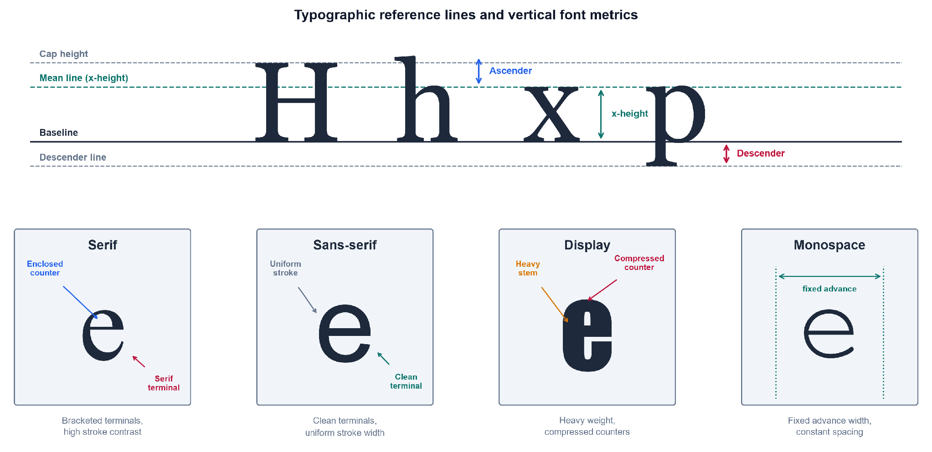
As shown in Figure 1, font identity is carried by fine-grained geometric traits rather than by the identity of the character itself, which is why this thesis reasons over visual texture instead of textual meaning.

3.2.2 Convolutional Neural Networks and Visual Feature Extraction
The dominant deep-learning tool for reading such visual traits is the convolutional neural network (CNN), an architecture that exploits the spatial structure of images through local, weight-sharing operations (LeCun, Bengio, & Hinton, 2015). Its central operation is convolution, in which a small kernel (also called a filter, a compact matrix of learnable weights) is slid across the image, computing a weighted sum at every position:
$(I*K)(i,j)=\sum_{m}{}\sum_{n}{}I(i+m, j+n) K(m,n) (1)$
Here $I$ is the input image (a two-dimensional array of pixel intensities), $K$ is the kernel, $(i,j)$ is the output spatial location, and $m,n$ index positions within the kernel. The resulting array is a feature map, an image in which each value records how strongly the kernel’s pattern (an edge, a corner, a serif) is present at that location. The region of the input that influences a single feature-map value is that value’s receptive field; stacking convolutional layers enlarges the receptive field, so deeper layers respond to progressively larger and more abstract structures (Goodfellow, Bengio, & Courville, 2016). The spatial size $O$ of a feature map is determined by the input and kernel geometry:
$O=⌊\frac{W−F+2P}{S}⌋+1 (2)$
where $W$ is the input width (in pixels), $F$ is the kernel size, $P$ is the amount of zero-padding added to the border, $S$ is the stride (the step size between kernel positions), and $⌊⋅⌋$ denotes the floor function. Between convolutional layers, pooling downsamples each feature map, usually by taking the maximum value in each small window, which shrinks the representation and grants tolerance to small shifts in glyph position (Sarker, 2021). Figure 2 presents this convolution-pooling-classification pipeline.
Figure 2
Simplified Architecture of a Convolutional Neural Network
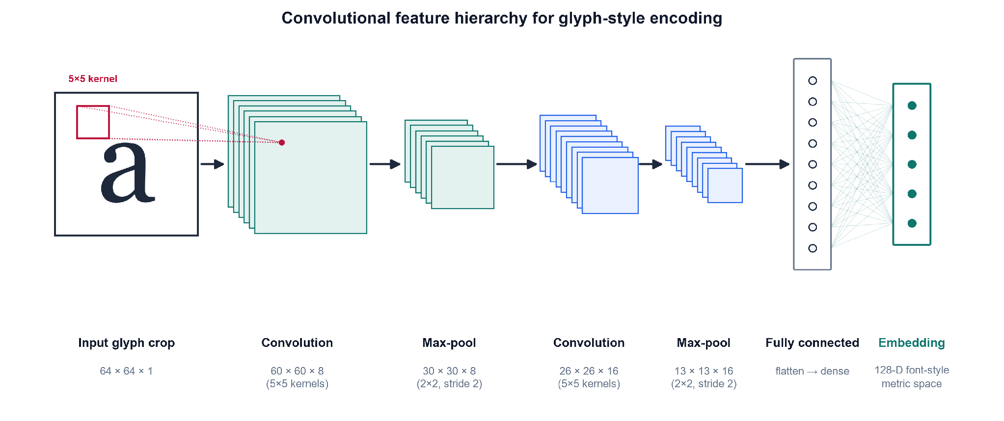
Note. Adapted from LeCun, Bengio, and Hinton (2015) and Goodfellow, Bengio, and Courville (2016).
As shown in Figure 2, a CNN processes an image through successive convolution and pooling stages before a fully connected block. This staged processing produces the hierarchical feature learning on which later chapters depend.

3.2.3 Typographic Hallucination
The input distribution this thesis targets is not clean type but typographic hallucination: the probabilistic glyph deformation introduced when generative AI image models render text, including micro-warping, elastic distortion, and variable kerning (inconsistent spacing between characters). Kondo et al. (2024) demonstrate that diffusion models natively emit novel, unclassified glyph geometries when interpolating in latent space. This establishes that the deformations are an intrinsic output of the model class rather than an occasional artifact. To make this precise, hallucination is modeled here as a degradation operator $D$ applied to a pristine glyph crop:
$\tilde{x}=D\left(x; θ_{warp}, θ_{blur}, θ_{kern}\right) (3)$
where $x$ is the clean rendered crop, $\tilde{x}$ is the resulting hallucinated crop, and $D$ composes three parameterized corruptions: an elastic warp (governed by $θ_{warp}$), Gaussian blur and noise ($θ_{blur}$), and kerning jitter ($θ_{kern}$). This operator, illustrated in Figure 3, is the formal object the synthetic-data pipeline of Chapter 4 will instantiate to train a deformation-robust recognizer. Modeling degradation as controlled, layered augmentation follows established practice: Plastropoulos and Tegos (2024) show that combining such transformations with deep feature extraction forces networks to learn resilient, continuous shape boundaries.
Figure 3
The Typographic-Hallucination Degradation Pipeline
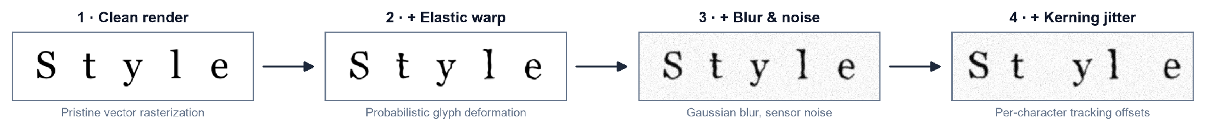
As shown in Figure 3, each stage of $D$ moves the glyph further from its pristine form and reproduces the exact deformations that cause commercial font identifiers to fail.

3.2.4 Embedding Spaces
Rather than emit a single hard label, the framework maps each crop into an embedding: a fixed-length vector of real numbers, produced by a deep network, that summarizes the visual content of the input. The set of all such vectors forms an embedding space, a continuous geometric space in which proximity encodes similarity, so that crops set in the same typeface should land close together and crops from different typefaces far apart (LeCun, Bengio, & Hinton, 2015). Representing fonts as points in a continuous space, rather than as entries in a fixed list, is what allows a hallucinated crop to be placed near its source typeface even when it matches none exactly. This is the property that the next section’s theoretical foundations formalize.

3.3 Theoretical Foundations
Having defined the visual objects and the network that reads them, this section develops the mathematics that turns embeddings into decisions. It moves from the general question of how a model can be trained at all to the two specific mechanisms this thesis assembles: metric learning, which shapes the embedding space so that distance means typographic similarity, and open-set recognition, which lets the system refuse to answer when a crop belongs to no known font.

3.3.1 Learning Paradigms
A deep network is trained by minimizing a loss function, a scalar-valued function that measures the gap between the model’s output and the desired output; optimization adjusts the network’s weights to make this quantity small. How the desired output is supplied defines the learning paradigm. In supervised learning, every training image carries a label (a human-assigned ground-truth answer, such as the font name), and the loss penalizes disagreement between prediction and label (Sarker, 2021). In unsupervised learning no labels exist, and the model must discover structure, such as clusters or densities, from the raw inputs alone. Self-supervised learning occupies the middle ground: it manufactures a supervisory signal from the data itself, for instance by asking the network to make two augmented views of one image agree, and so gains the benefits of supervision without manual annotation. This distinction matters here because in-the-wild generative-AI crops arrive without font labels, which pushes the thesis toward metric and self-supervised formulations rather than a purely supervised classifier.

3.3.2 Metric Learning and Embedding Distance
Metric learning is the family of methods that trains an embedding function $f_{θ}$ (a network, with parameters $θ$, that maps an input crop to a vector) so that geometric distance in the output space corresponds to semantic similarity (Schroff, Kalenichenko, & Philbin, 2015). Two distances are used to compare embeddings. The Euclidean distance between two crops $a$ and $b$ is
$d(a,b)={‖f(a)−f(b)‖}_{2}, (4)$
where $f(a)$ and $f(b)$ are their embedding vectors and ${‖⋅‖}_{2}$ is the $L^{2}$ (straight-line) norm; smaller $d$ means greater similarity. Cosine similarity instead measures the angle between the two vectors,
$cos(a,b)=\frac{f(a)⋅f(b)}{‖f(a)‖ ‖f(b)‖}, (5)$
where $f(a)⋅f(b)$ is the dot product; it ranges from $−1$ to $1$ and ignores vector magnitude, so it captures only direction.
To force these distances to encode font identity, the embedding is trained with a triplet loss. A triplet consists of an anchor crop $a$, a positive $p$ set in the same typeface as the anchor, and a negative $n$ set in a different typeface. The loss is
$L=\sum_{i}{}{\left[ {‖f(a_{i})−f(p_{i})‖}^{2}−{‖f(a_{i})−f(n_{i})‖}^{2}+α \right]}_{+}, (6)$
where the sum runs over triplets, $α$ is the margin (a minimum required gap between the anchor-positive and anchor-negative distances), and $[ ⋅ ]_{+}=max(0,⋅)$ keeps only positive violations (Schroff et al., 2015). Minimizing $L$ pulls same-font crops together and pushes different-font crops apart by at least $α$. FaceNet established this on face identity, but it was validated only on clean, photographic faces, not on deformed glyphs. Two further results extend the rationale to the regime here. Huang and Zhou (2022) show that deep networks can decompose complex visual domains into structured feature vectors that support continuous proximity rankings rather than hard label buckets, and Umer et al. (2022) provide the optimization backing for tracking structural closeness on high-variance, distorted geometries. A cleaner space still helps: Wang et al. (2024) impose a non-negativity constraint on contrastive features, which yields sparse, axis-aligned embeddings, though their guarantees are also demonstrated on standard benchmarks rather than on typographic deformation.

3.3.3 Open-Set Recognition and Rejection Scores
A metric embedding still assumes every query belongs to some trained class. Open-set recognition removes that assumption: it partitions inputs into known classes (fonts seen in training) and the unknown class (anything else), and must reject the unknown instead of forcing it into a known bucket. The formal hazard is open-space risk $R_{O}(f)$, which is roughly the fraction of the large “open space” far from any training example that a recognizer nonetheless labels as a known font. Because a bounded amount of training data cannot fence off an unbounded space, minimizing $R_{O}(f)$ requires a rejection score (a scalar that summarizes how confidently an input belongs to any known class), compared against a threshold below which the input is declared unknown (Lu et al., 2025). Figure 4 depicts this geometry.
Figure 4
Embedding Space with Known-Font Clusters and an Open-Set Rejection Boundary
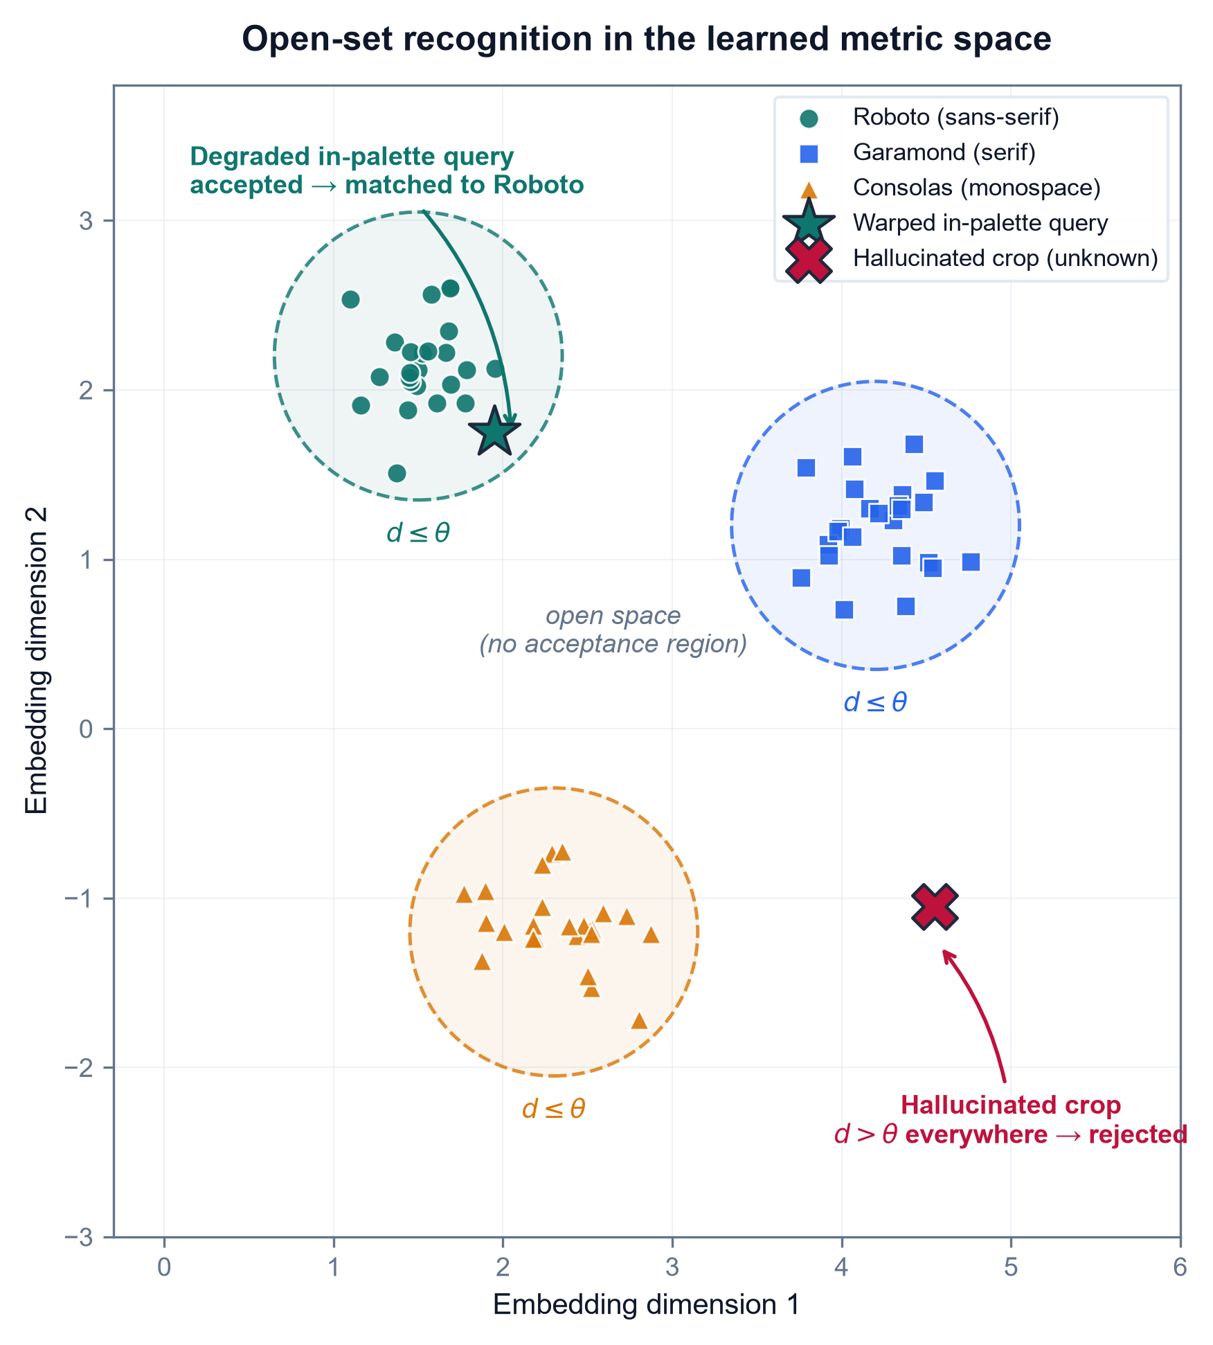
As shown in Figure 4, known typefaces form compact clusters while a hallucinated, out-of-palette crop lands in the open region beyond the rejection boundary, which is the case a threshold on the rejection score is meant to catch.
The rejection score can be read at several points in the network. Many scores start from the logits (the raw, pre-normalization outputs $f_{i}(x)$ of the classification layer for each class $i$), which the softmax function converts to a probability distribution,
$σ(z)_{i}=\frac{e^{z_{i}}}{\sum_{j}{}e^{z_{j}}}, (7)$
where $z_{i}$ is the logit for class $i$ and the denominator sums over all classes so the outputs total one. Softmax confidence alone is a poor rejection score because networks are overconfident off-manifold; the recent literature therefore reads richer signals. Hofmann et al. (2024) compute an energy score,
$E(x)=−T⋅log\sum_{i}{}exp​\left(f_{i}(x)/T\right), (8)$
where $T$ is a temperature constant and the sum runs over class logits; low energy indicates an in-distribution input and high energy flags the unknown, and they sharpen the boundary by mining hard outliers near it. Djurisic et al. (2024) keep the decision in logit space but rescale the whole logit vector by a feature-derived scalar before thresholding, and this requires no retraining. Karunanayake et al. (2025) argue that the ranking of the runner-up classes is itself diagnostic, and far more deterministic for known inputs than for unknown ones. This idea maps directly onto a Top-K font shortlist, where the order of the second- and third-place fonts signals a hallucinated glyph. The limitation that ties all four together is that every one of these scores is validated on natural-image out-of-distribution benchmarks (CIFAR, ImageNet). None has been tested on typographic out-of-distribution input, the probabilistic warping and variable kerning this thesis targets. Whether these scores transfer to font hallucination over a localized palette is the question the methodology sets out to answer.

3.4 Existing Technologies & Frameworks
The theory of the previous section is realized through concrete software tools and neural architectures. This section surveys the ones the methodology builds on. Because every framework should be judged on both sides, each is paired with what it does well and where it falls short on this thesis’s deformed-glyph regime. The tools divide into a representation stack (a library, a backbone architecture, a frozen encoder, and a parameter-efficient adaptation method) and a measurement stack (structural-similarity metrics), followed by the generative process that produces the input distribution in the first place.

3.4.1 PyTorch and the Vision Transformer Backbone
A deep-learning framework is a software library that supplies the building blocks (tensor operations, automatic differentiation, and pre-built layers) for defining and training networks. PyTorch is the framework adopted here; its central strength is a dynamic computation graph, which means the network structure is defined on the fly as code executes, together with autograd, which automatically computes the gradients that optimization needs. This flexibility makes PyTorch well suited to research prototyping, but it is deliberately domain-agnostic: it provides no built-in typographic priors, so all font-specific structure must be supplied by the model and data the researcher constructs.
The backbone architecture is the Vision Transformer (ViT), which processes an image not through convolution but by splitting it into a grid of fixed-size patches, flattening each patch into a patch embedding (a vector), and letting the patches interact through self-attention. Self-attention, introduced by Vaswani et al. (2017), lets every element of a sequence weigh the relevance of every other element. Each patch embedding is projected into three vectors, a query $Q$, a key $K$, and a value $V$, and the operation is
$Attention(Q,K,V)=softmax​\left(\frac{QK^{⊤}}{\sqrt{d_{k}}}\right)V, (9)$
where $QK^{⊤}$ scores how well each query matches each key, $d_{k}$ is the key dimension whose square root rescales the scores to keep them numerically stable, softmax turns the scores into weights summing to one, and $V$ carries the aggregated content. Figure 5 depicts this patch-embedding-and-attention flow.
Figure 5
Vision Transformer Patch Embedding and Self-Attention
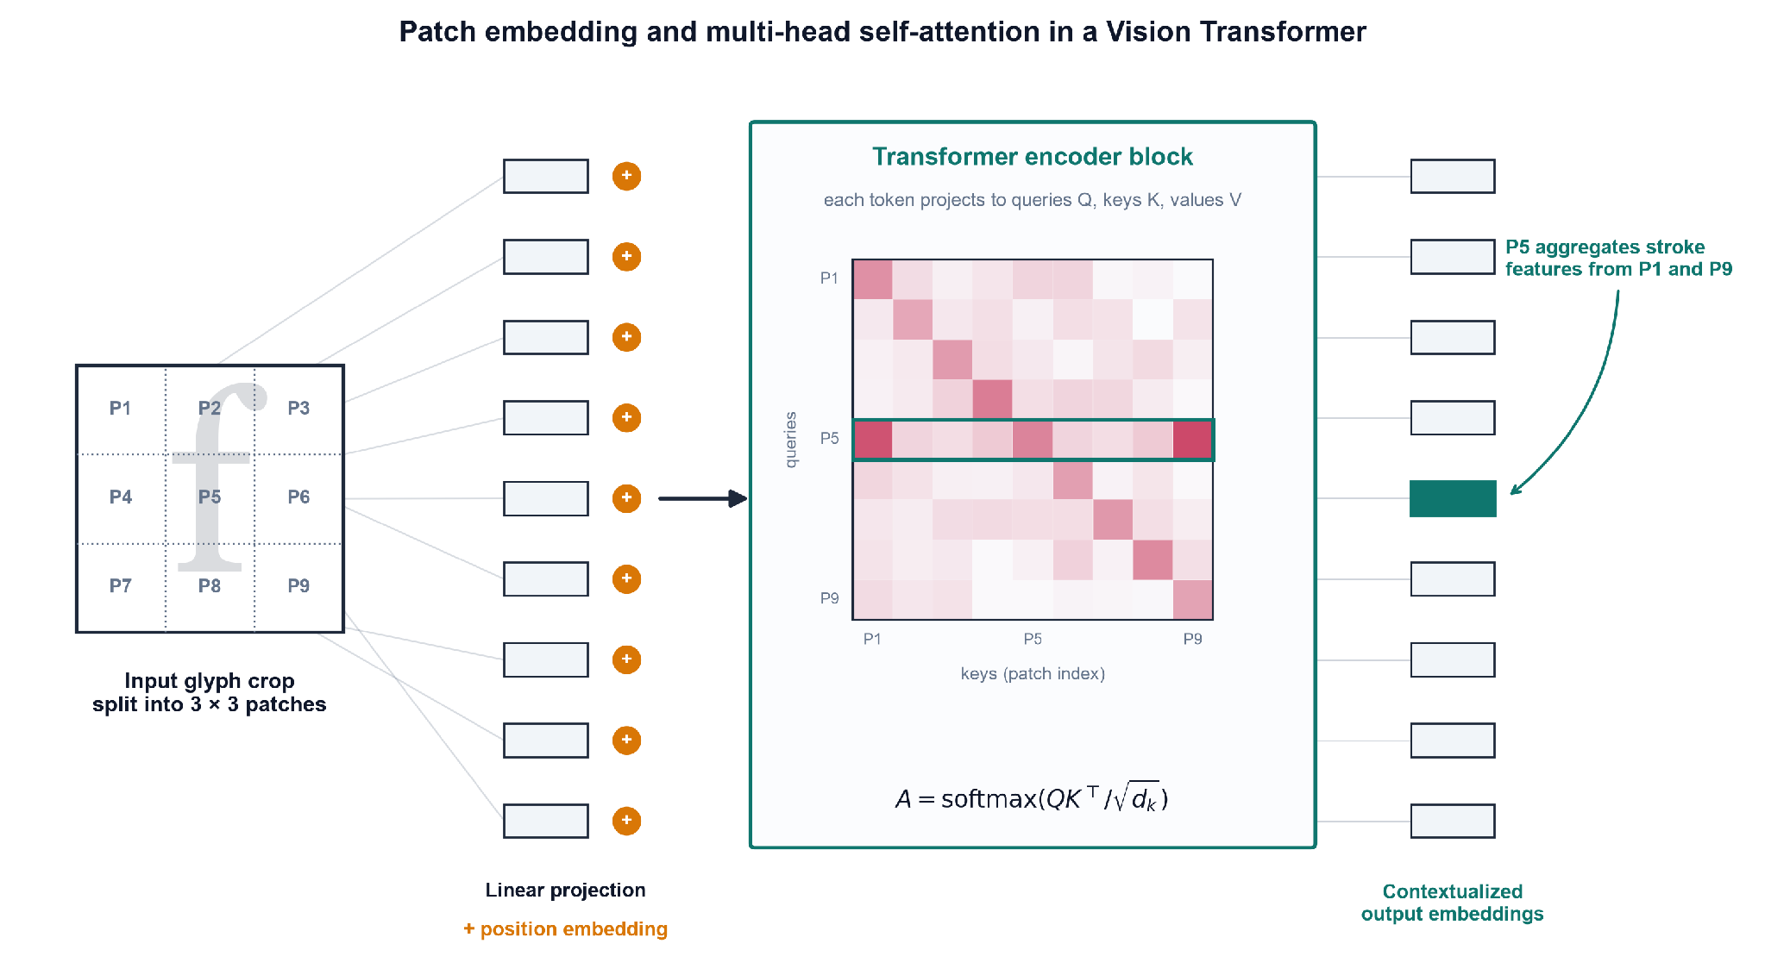
Note. Adapted from Vaswani et al. (2017) and Wang, Lv, et al. (2025).
As shown in Figure 5, self-attention links spatially distant patches directly, which is why Wang, Lv, et al. (2025) use a ViT to parse long-range document layout that fixed convolutional receptive fields cannot span. The limitation is twofold: self-attention is data-hungry and needs large training sets to generalize, and its all-pairs comparison has quadratic cost in the number of patches, which makes high-resolution inputs expensive.

3.4.2 Self-Supervised Frozen Encoders
Training a ViT from scratch is the data-hungry step this thesis wants to avoid. DINOv2 (Oquab et al., 2024) is a ViT trained by self-supervised distillation to produce all-purpose visual features that transfer to fine-grained classification and retrieval with no fine-tuning. Used as a frozen encoder, with its weights held fixed while only downstream components are trained, it lets the framework read patch-level embeddings from a glyph crop without building a font-specific network from scratch, and Sheikh et al. (2024) show the same frozen-DINO family extract layout structure with no labels at all. Its weakness is that these features are not clean: Darcet et al. (2024) identify high-norm artifact tokens that self-supervised ViTs repurpose for internal computation in low-information image regions, which corrupts the feature map. Their fix is register tokens (extra dedicated tokens that absorb this internal computation), which restore smooth attention and feature maps. That repair matters directly for glyph crops, whose informative signal is a few thin strokes on empty ground; yet, like the backbone itself, registers are validated only on natural images, never on re-rendered type.

3.4.3 Parameter-Efficient Fine-Tuning
A frozen encoder trades adaptation for economy: its weights never move, so it cannot specialize to type. Full fine-tuning restores that specialization but at prohibitive cost, updating all of the backbone’s parameters (87.2 million for a ViT-B/14) and storing a full copy per task. Parameter-efficient fine-tuning (PEFT) is the middle path, adapting a large pre-trained model to a new task by training only a small set of new parameters while the original weights stay frozen. The dominant PEFT method is Low-Rank Adaptation (LoRA), which rests on the observation that the update a model needs for a new task has low intrinsic rank. Rather than learn a full weight-update matrix $ΔW$ for a layer, LoRA factors it into two thin matrices:
$W^{′}=W_{0}+ΔW=W_{0}+\frac{α}{r} BA, (10)$
where $W_{0}$ is the frozen pre-trained weight matrix, $A$ and $B$ are the trainable low-rank factors (with $A∈R^{r×k}$, $B∈R^{d×r}$), $r$ is the rank (a small integer, e.g. $r=8$, that bounds how much the update can express), and $α$ is a scaling factor that controls the update’s magnitude. Because $r$ is far smaller than the layer’s dimensions, the product $BA$ reconstructs a full-size update from a tiny number of parameters. Chen et al. (2026) adapt a frozen DINOv2 ViT-B/14 to font classification this way with $r=8$ and $α=16$, training roughly 150,000 parameters — about 0.2% of the backbone — and reach approximately 86% Top-1 accuracy across 394 Google Font variants, with the trained factors mergeable back into $W_{0}$ so inference incurs no added cost. The strength is decisive economy: the frozen backbone preserves its general visual knowledge while a negligible adapter specializes it, avoiding both the compute of full fine-tuning and the label-free ceiling of a purely frozen encoder. The limitations are equally direct and shape this thesis’s design. LoRA adaptation is supervised and closed-set — Chen et al. train on labeled synthetic renders over a fixed 394-class catalogue — and their model, trained exclusively on pristine synthetic type, is self-reported to fail on photographs and heavily styled graphics; its residual errors concentrate between near-identical weight variants of the same family (family-level accuracy falls to 40.2%), which the authors attribute to detail lost at the 224×224 input resolution. PEFT thus offers a cheap route to a specialized typographic encoder, but one whose closed-set, clean-glyph training is the very regime this thesis’s open-set, deformation-robust framing is built to move beyond.

3.4.4 Structural-Similarity Metrics
To score how well a predicted font matches a crop, the framework needs a structural-similarity metric, a measure of perceptual, structural agreement rather than pixel-by-pixel identity. The original one is the Structural Similarity Index (SSIM) of Wang et al. (2004), which models similarity as a product of luminance, contrast, and structure terms:
$SSIM(x,y)=\frac{(2μ_{x}μ_{y}+C_{1})(2σ_{xy}+C_{2})}{(μ_{x}^{2}+μ_{y}^{2}+C_{1})(σ_{x}^{2}+σ_{y}^{2}+C_{2})}, (11)$
where $μ_{x},μ_{y}$ are the mean intensities of the two image windows $x$ and $y$, $σ_{x}^{2},σ_{y}^{2}$ their variances, $σ_{xy}$ their covariance, and $C_{1},C_{2}$ small constants that prevent division by zero. SSIM is interpretable and computationally light, but classical pixel-SSIM collapses under geometric misalignment (when the two images are warped or shifted relative to each other), which is the normal case for a hallucinated glyph. Figure 6 illustrates the re-render-and-compare protocol this metric serves.
Figure 6
Structural-Similarity Re-Render-and-Compare Pipeline
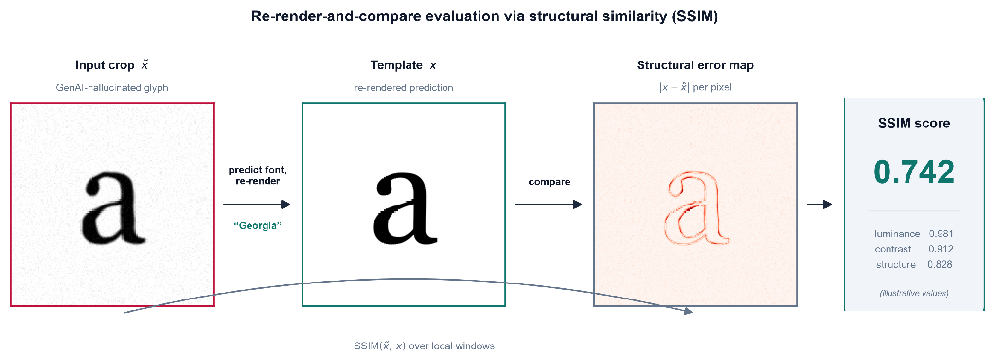
As shown in Figure 6, the predicted typeface is re-rendered and scored against the input crop, which is where classical SSIM’s alignment assumption breaks. Two deep successors address this: Zhang et al. (2024) compute DeepSSIM over deep feature maps with an attention-calibration step, which keeps the score valid under geometric misalignment, and Li et al. (2025) build SAMScore on segmentation-model embeddings to measure whether a transformed image preserves source content structure. Both are deformation-robust in principle, but both were validated on natural-image translation tasks, never on re-rendered glyphs. That untested transfer is what this thesis must confront.

3.4.5 Latent Diffusion as the Generative Source
Finally, the input distribution itself originates from latent diffusion, the class of generative models that synthesize images by iteratively denoising a compressed latent representation. Kondo et al. (2024) show that interpolating in this latent space natively emits novel, unclassified glyph geometries with fluid visual traits, which is peer-reviewed evidence that typographic deformation is intrinsic to the model class. Its strength as a generator is its weakness for this thesis: the process is uncontrolled with respect to font identity and produces glyphs that belong to no catalogued typeface. Diffusion is therefore the source of the problem this framework must handle, not a solution to it. That is why the thesis treats its deformed output as the input distribution, which the following chapter’s pipeline is built to handle.

3.5 Problem Context
Having assembled the concepts, theory, and tooling, this section states why no existing solution suffices on the input distribution this thesis targets: the in-the-wild GenAI crop, a fragment of text lifted from a generative-AI image whose glyphs are probabilistically deformed rather than pristine. Each mature tool works well on the distribution it was built for and fails on this one.
Classical OCR and closed-boundary layout analysis are the first casualty. Ponnuru et al. (2024) digitize smudged, handwritten prescriptions at a 98% accuracy baseline, which shows that traditional pipelines handle environmental noise on anatomically correct text with ease; but their adaptive-thresholding and bounding-box machinery presupposes rigid glyph geometry, which the topological warping of hallucinated type dissolves. The DeepFont-style font-classify baseline established in Section 3.2 fails for a different reason: trained on clean synthetic glyphs, it is pristine over-fit (tuned so tightly to geometrically exact vectors that deformed input falls off its learned manifold) and closed-set (it assumes every query belongs to a catalogued class and is therefore forced to return some known font even when the true typeface is absent). The measurement tools inherit the same brittleness: classical pixel-SSIM (Section 3.4) demands pixel registration, an exact per-pixel correspondence between the two images, which warped, re-kerned glyphs break outright. A general vision-language model is no escape either; Li, Song, et al. (2025) show that state-of-the-art VLMs get lost in font recognition, derailed by the word’s semantic content instead of reading its visual texture. Even the closest typographic precedent falls short: the L2@k and cos@k font-fidelity metrics of Jiang et al. (2025), computed over the very Storia-AI classifier this thesis adopts as its baseline, assume an undeformed input glyph and so cannot faithfully score a hallucinated crop. That the deformation is endemic rather than incidental is settled by Liu et al. (2024), who find that an uncorrected generative pipeline renders text correctly less than 20% of the time, which is the empirical size of the problem this thesis exploits.
These failures converge on a single consolidated gap. No existing framework couples an attention-isolated text crop → a deformation-robust, frozen-ViT metric embedding → open-set font-identity ranking with a calibrated Top-K over a localized open-set palette (the top 50 to 100 Google Fonts) on the GenAI-deformed input distribution. Figure 7 previews the end-to-end framework this thesis assembles to fill that gap.
Figure 7
End-to-End Architecture of the Proposed Font-Style Recognition Framework
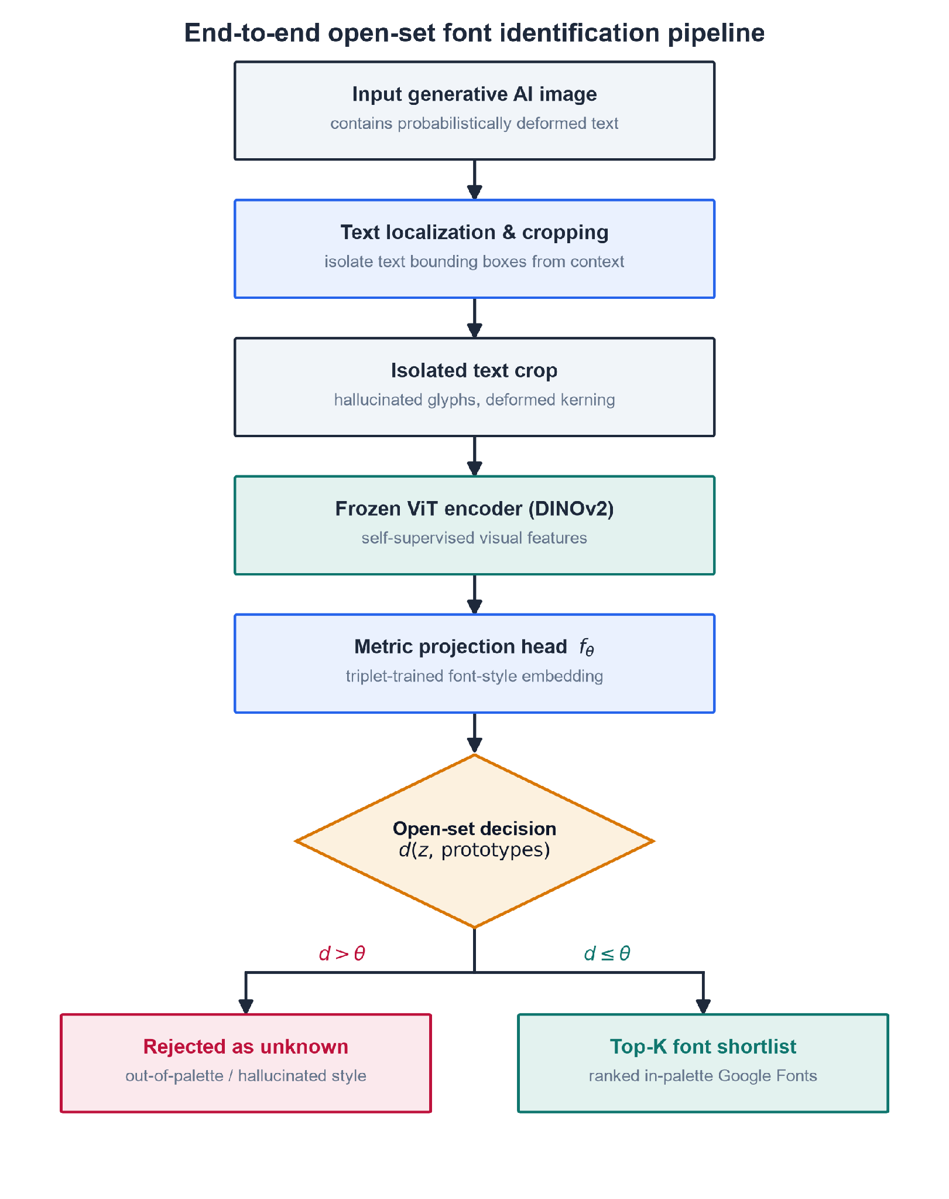
As shown in Figure 7, an isolated crop flows through the frozen-ViT encoder into a metric embedding, where an open-set rejection score and a calibrated Top-K produce a ranked shortlist over the localized Google-Fonts palette. This is the coupling that the preceding tools, taken one at a time, leave unbuilt.
Having established the typographic, deep-learning, metric-learning, and open-set foundations, along with the specific technical gap they leave open, the next chapter details the synthetic-degradation pipeline that manufactures deformed training data, the model architecture that embeds and ranks each crop, and the evaluation protocol that measures the framework against a human-proxy baseline.

Chapter 4: Methodology

4.1 Research Environment and Respondents
This study is conducted in a fully computational research environment. It does not draw on a human population but instead studies typographic artifacts. The units of analysis are therefore not people but fonts and the rendered text-crop images derived from them. Because the study addresses typographic hallucination in generative AI images, no clean corpus of such crops exists at the scale a metric-learning model requires. The environment is consequently a synthetic-data one: the primary dataset is generated by the researchers from a curated, open-source font palette rather than downloaded ready-made. This follows the precedent of DeepFont, which likewise built a targeted synthetic dataset of rendered glyphs to train a deep visual font recognizer (Wang et al., 2015).

Digital Source and Trusted Environment
The font palette is sourced from Google Fonts (https://fonts.google.com; source repository https://github.com/google/fonts), the open-source typeface library maintained by Google LLC. Google Fonts is a trusted environment for three reasons. First, its faces are released under permissive open licenses (predominantly the SIL Open Font License), so every typeface can be freely rendered, degraded, and redistributed without the licensing constraints that encumber commercial font catalogues. Second, the collection is curated and version-controlled, giving each typeface a stable identity and provenance that a reproducible dataset requires. Third, its faces are among the most widely deployed on the web, so a model trained on them maps hallucinated text back onto a realistic, free reconstruction palette. From this library the study selects the top 50 to 100 Google Fonts, drawn from the platform’s own popularity ordering and chosen to span the four structural family classes (serif, sans-serif, display, and monospace) established in Section 3.2.1.
The decision to bound the palette this tightly is deliberate, and it follows from both the framework’s design and the evidence on large catalogues. Conceptually, the system is built for open-set recognition, in which the known set is intentionally finite and every out-of-palette input is routed to an “unknown” verdict; because the space of possible fonts is effectively unbounded and cannot be enumerated (Lu et al., 2025), a localized known set is the premise of the design rather than a limitation of it. Empirically, scaling the catalogue buys coverage, not robustness. The 3,474-font Storia-AI classifier is the field’s largest reference embedding, yet it still overfits pristine glyphs and degrades under generative deformation (Jiang et al., 2025), and Chen et al. (2026) show that pushing to 394 variants drops family-level accuracy to 40.2%, because the additional fonts are largely near-identical weight variants whose confusion dominates the error matrix. A curated palette that omits redundant near-duplicates avoids that failure mode directly. The trimmed set also excludes the typographic long tail of rare and display faces, which is both the hardest to recognize and the most severely hallucinated by diffusion models (Zhuang et al., 2025), and it keeps per-class image density high for the metric-learning objective, since a fixed rendering budget spread over fewer classes yields more examples per font. Finally, the study’s reconstruction goal only requires the faces designers actually reuse, which the popularity ordering already surfaces.
A second, external repository defines the study’s comparative baseline: Storia-AI’s Google Font Classifier (the font-classify/ sandbox), a pre-trained classifier over 3,474 Google Fonts. The classifier was chosen because it is the field’s reference embedding for font identity, adopted as the fidelity backbone in recent typographic work (Jiang et al., 2025). Benchmarking against it lets the study demonstrate, on a recognized standard, how weights fitted to pristine glyphs degrade under generative-AI deformation.

Respondents: The Entities Being Studied
Because the data concern non-human objects, there are no human respondents in the primary sense. The entities being studied are of two linked kinds:
- Fonts (typefaces). The 50 to 100 selected Google Fonts are the population of typographic identities the system must recognize. Each font is one class label in the recognition problem and is characterized by the measurable structural traits defined in Chapter 3 (x-height, terminal form, stroke contrast, and counter shape).
- Rendered text-crop images. From each font the pipeline renders pristine word crops and then applies the algorithmic degradation operator of Section 3.2.3 to produce hallucinated variants. These grayscale image crops (standardized to a fixed input resolution, detailed in Section 4.3.1) are the individual “profiles” the model actually consumes; each degraded crop is an instance whose ground-truth label is the font it was rendered from.
The unit of analysis is the isolated text crop, not the full image. A real deployment receives a whole generative-AI image, which may contain several text regions in different fonts, so an upstream step must first locate and crop each region. That localization is handled by a standard off-the-shelf text detector and is treated as a delimitation rather than a contribution: this study does not train, tune, or evaluate the localizer, and it reports no detection metrics. Every crop the localizer emits is classified independently by the recognition engine, which is where the thesis’s contribution lies. Fixing the crop as the unit of analysis keeps the dataset, the metrics of Section 4.2, and the human-proxy baseline all defined at the same level.
A small human element enters only at the evaluation stage, and strictly as a benchmark rather than a training population: a three-person consensus panel establishes a human-proxy ground truth over a held-out set of 100 actual generative-AI image text boxes. This panel provides the accuracy floor against which the automated system is compared (elaborated in Section 4.10); its composition and screening criteria are specified there. Because the raters are practicing typography and design professionals for whom a synchronous, face-to-face labeling session would be impractical to convene, the panel operates in a remote, asynchronous online environment: each rater completes the rating exercise independently through a web-based form, at their own pace and without a shared session or contact between raters. The distributed setup also preserves rater independence by construction, since no rater can observe another’s judgments before submitting, and it keeps the environment reproducible because every rater receives the identical instrument over the identical crop set. The administration of that form is detailed in Section 4.2.3. Apart from this proxy panel, the study’s respondents are entirely typographic artifacts.

4.2 Research Instrument or Sources of Data
Because this study works on typographic artifacts rather than human respondents, its “instruments” are the software apparatus that manufactures, measures, and adjudicates the data rather than a questionnaire or survey. Four instruments are used: a researcher-made synthetic-data generation pipeline that produces the training and validation corpus, a set of standardized evaluation metrics that score the model’s output, a researcher-made human-proxy consensus rubric that fixes ground truth on real generative crops, and a web application that exercises the trained model in real time. The first three supply and assess data; the fourth is the interactive artifact through which the system is demonstrated and stress-tested.

4.2.1 Synthetic-Data Generation Pipeline (Researcher-Made)
The primary instrument is a researcher-built rendering-and-degradation pipeline. Its purpose is to generate a large, fully labeled corpus of text-crop images for which no in-the-wild equivalent exists at the scale metric learning requires, following the synthetic-corpus precedent of DeepFont (Wang et al., 2015) and the more recent DINOv2-based font pipeline of Chen et al. (2026). The instrument has two stages. The rendering stage draws pristine word crops from the selected Google Fonts palette; the degradation stage applies the operator $D$ defined in Section 3.2.3 (elastic warp, Gaussian blur and noise, and kerning jitter) to convert each pristine crop into a hallucinated variant.
The instrument’s construct validity rests on the correspondence between its degradation parameters and the deformation mechanisms the generative literature documents: cross-character attention smearing (Gillani et al., 2025), multi-instance entanglement (Du et al., 2025), and continuous latent-manifold mutation (Kondo et al., 2024). In other words, the pipeline is valid to the extent that its manufactured deformations reproduce those observed in real text-to-image output. Its reliability is guaranteed procedurally: rendering and degradation are deterministic given a fixed random seed, so any crop in the dataset can be regenerated bit-for-bit, and the per-parameter degradation levels are logged with each image. This distinguishes the instrument from a standardized dataset, since it is researcher-made, but its determinism makes it reproducible by any third party who runs the same code with the same seed.

4.2.2 Standardized Evaluation Metrics
The model’s output is scored with published, standardized metrics rather than researcher-defined ones, which imports their established validity. Recognition accuracy uses the Top-1 and Top-3 (Top-K) protocol that DeepFont established as the field standard (Wang et al., 2015). Typographic proximity between a predicted font and the input crop is measured with structural-similarity metrics in a re-render-and-compare loop: the classical SSIM of Wang et al. (2004) and its deformation-robust successors DeepSSIM (Zhang et al., 2024) and SAMScore (Li, Chen, et al., 2025), whose reliability under geometric misalignment is exactly the property this study needs. Prediction-set confidence uses rank-calibrated conformal prediction (Shi et al., 2024; Ding et al., 2025), which carries a formal coverage guarantee. Finally, error severity is weighted by the embedding-centroid cosine severity index of Chen et al. (2026), which quantifies whether misclassifications stay within a typographic family. Because these instruments are drawn from peer-reviewed sources, their validity and reliability coefficients are inherited from the literature rather than re-established here.

4.2.3 Human-Proxy Consensus Rubric (Researcher-Made)
Ground truth for real generative crops, which carry no font metadata, is fixed by a researcher-made rating instrument administered to a three-person expert panel. The instrument is delivered asynchronously as a web-based rating form rather than in a supervised session (the remote environment justified in Section 4.1): each crop is presented individually beside a reference sheet of the palette rendered as labeled specimens, so that raters match against a fixed, visible option set instead of recalling fonts from memory, and each rater works self-paced and blind both to the other raters and to the model’s predictions, which guards against anchoring. The form’s two screens, an instructions page and the per-crop rating item, are reproduced in the appendices; the layout is deliberately platform-neutral, so any standard web-form service can deliver it without altering the instrument. For each of the [N = 100] real generative-AI text boxes, each rater independently assigns a font label from the palette or an “unknown / hallucinated” verdict, and a label is fixed only when at least two of three raters agree. The instrument’s content validity comes from panel expertise (raters screened for typographic training, criteria specified in Section 4.10); its reliability is quantified by inter-rater agreement, reported as a Fleiss’ $κ$ of [κ = X.XX] once the rating exercise is run. The 2-of-3 consensus rule is the instrument’s built-in reliability safeguard against any single rater’s idiosyncrasy.

4.2.4 Web Application (Interactive Testing Instrument)
The fourth instrument is a web application built on top of the trained model so that the system can be exercised in real time rather than only in batch evaluation. A user uploads a generative-AI image through the browser, the backend runs the inference engine, and the interface returns the Top-K Google Fonts shortlist or an “unknown” verdict. The accepted input is a raster image in PNG (.png), JPEG (.jpg, .jpeg), or WebP (.webp) format up to 10 MB: these are the formats current text-to-image generators export and the forms in which their output circulates as screenshots and web re-shares. Vector formats such as SVG are refused because typographic hallucination is a raster artifact with no vector equivalent, and animated or photographic formats (GIF, HEIC) fall outside the study’s scope of directly generated still images. This instrument serves two methodological purposes: it is the demonstration artifact required by the build-method evaluation of Section 4.10, and it is a qualitative probe that surfaces failure cases on ad hoc, in-the-wild inputs that the fixed test set may not contain. Its design, framework choices, and development process are detailed in Sections 4.5 through 4.8.

4.3 Research Procedure
This section specifies how the data are gathered and treated. Section 4.3.1 defines the dataset schema, the variables, and the properties of the image and text data. Section 4.3.2 describes the preprocessing, augmentation, and adaptation applied before training, and closes with the validation strategy that guards against overfitting.

4.3.1 Gathering of Data
Data schema. The corpus is a table of image instances, one row per rendered crop, with the fields listed in Table 1. Each row pairs an image file with the metadata needed to train, stratify, and audit it.
Table 1
Schema of the Synthetic Text-Crop Dataset
Field | Type | Description
image_id | string | Unique identifier for the crop
image_path | string | Path to the rendered PNG
font_id | categorical | Google Fonts family and weight (the class label)
family_class | categorical | Serif, Sans-serif, Display, or Monospace
word_text | string | The rendered English word(s)
warp_level | float | Elastic-warp intensity $θ_{warp}$
blur_level | float | Gaussian blur/noise intensity $θ_{blur}$
kern_level | float | Kerning-jitter intensity $θ_{kern}$
split | categorical | train, validation, or test
seed | integer | Random seed for exact regeneration
Note. The three degradation-level fields record the parameters of the operator $D$ from Section 3.2.3, so each crop’s deformation is reproducible and can be analyzed after the fact.
Variables. The independent variables (inputs) are the pixels of the rendered text-crop image and, at a controlled level above them, the three degradation parameters ($θ_{warp}$, $θ_{blur}$, $θ_{kern}$) that the pipeline manipulates systematically, together with the categorical family_class factor used to analyze errors. The dependent variable (target) is the font class label, one of the 50 to 100 palette fonts, plus the open-set “unknown” outcome for crops belonging to no palette font. Secondary outcomes measured from the model are the Top-K rank of the true font, the structural-distance score between the input and the re-rendered prediction, and the open-set rejection score.
Image properties. Crops are rendered at 1024 px and downsampled to a fixed 224 × 224 input, which matches the DINOv2 ViT-B/14 backbone and the resolution used by Chen et al. (2026). To keep the model from learning a color shortcut, and to mirror the varied coloring of real generative text, foreground and background colors are randomized during rendering with a minimum luminance contrast of 80 (the Chen et al. precedent). Each crop is then reduced to single-channel luminance and replicated across three channels for ImageNet-normalized input, so the encoder reads grayscale structure while training on color-varied renders. Text alignment is jittered (left, center, or right) and lines wrap with roughly 20% probability, and about 575 images are rendered per font variant as the per-class volume baseline.
Text properties. The rendered strings are English (Latin script), drawn from a fixed word list of common words so that lexical content is decorrelated from font identity across the corpus. Each crop carries one to three words, so the visual field is dominated by letterform structure rather than long-line layout.
Extension beyond the precedent. Chen et al.’s (2026) augmentation is pristine-noise only (Gaussian $σ=25.5$). This study’s data contribution is to add the hallucination-specific degradation operator $D$, covering elastic warp, kerning jitter, and cross-character smear, that their closed-set pipeline lacks. As a result the corpus covers the probabilistic glyph deformation that defines the target regime, which clean renders under noise never reach.
The real-generative evaluation set. A second, smaller body of data is collected rather than rendered, to test the trained model on genuine in-the-wild deformation instead of the study’s own synthetic operator. It consists of [N = 100] text crops isolated from real images produced by current text-to-image generators such as DALL·E, Midjourney, and Stable Diffusion, the tools whose typographic hallucination motivates the study. Each source image is passed through the same off-the-shelf localizer used at deployment (Section 4.1), and every text box it emits becomes one evaluation crop, so the unit of analysis is identical to the synthetic corpus. Because these crops carry no embedded font metadata, their ground-truth labels are fixed by the human-proxy panel (Section 4.2.3), and the set is held out from training entirely (Section 4.3.2).
Selecting the crops. The [N = 100] crops are sampled purposively rather than at random, under a quota that spans the two factors that drive recognition difficulty: the four structural family classes (serif, sans-serif, display, monospace) and a graded range of hallucination severity from mild to severe, gathered across more than one generator so the benchmark is not dominated by a single tool’s failure signature. This mirrors the family-and-degradation stratification of the synthetic split (Section 4.3.2) and ensures the human-proxy accuracy floor is estimated over the full difficulty range, not only easy cases.
Why one hundred. The set is deliberately small because every crop must be labeled independently by all three expert raters, roughly 300 judgments in total, so its size is bounded by expert effort rather than by data availability. One hundred is adequate for its role as a benchmark and accuracy floor rather than a training set: at $n=100$ a measured accuracy carries a worst-case 95% confidence half-width of about $±10$ percentage points, and the comparison it supports (the open-set model against closed-set baselines that collapse on deformed input, Section 4.10) targets gaps far larger than that margin, while finer-grained effects are left to the much larger synthetic test partition. The count is a planned target and may be revised upward if rater capacity allows.

4.3.2 Treatment of Data
Before training, each crop passes through a preprocessing chain embedded in the model’s forward pass (square-pad, resize to 224 × 224, and ImageNet normalization) rather than applied as a separate offline step. Folding preprocessing into the forward method, following Chen et al. (2026), guarantees that the same transforms run at training and at inference, which eliminates train-serve skew when the model is later called from the web application. Degradation via the operator $D$ is applied online as a stochastic augmentation, so a given font is seen across a distribution of deformation amplitudes within and across epochs. Following the augmentation-as-coverage argument of Plastropoulos and Tegos (2024), this pushes the decision boundary into regions that stay stable under distortion.
Adaptation strategy. The default configuration keeps the DINOv2 backbone frozen and trains only a lightweight metric-embedding head (Section 2.5), because in-the-wild generative crops arrive without font labels and the open-set inference path must not depend on a closed-set classifier. Parameter-efficient fine-tuning (LoRA; $r=8$, $α=16$, about 0.2% of parameters) as used by Chen et al. (2026) is reserved for the supervised teacher that supplies reference distributions to the label-free prompt-distillation step. It is kept off the open-set inference path, whose closed-set assumptions it would otherwise reintroduce.
Validation strategy. The synthetic corpus is partitioned 70% / 15% / 15% into training, validation, and test sets, split by font_id and stratified so that every font class and every degradation level appears in each partition in proportion to its overall frequency. Stratification prevents a rare display or monospace face from landing entirely in one partition, which would otherwise inflate or deflate its apparent accuracy. Because per-class counts for the rarest faces are modest, stratified k-fold cross-validation ($k=5$) is used on the combined train-plus-validation data to stabilize the reported metrics, with the 15% test partition held out untouched until final evaluation. Separate from this synthetic split is the real-generative test set of [N = 100] in-the-wild crops (sourced, sampled, and sized in Section 4.3.1; labeled by the human-proxy panel, Section 4.2.3). It never enters training in any form, and it functions as the out-of-distribution generalization benchmark against which the synthetic-trained model is finally judged.

4.4 Concept

4.4.1 Core Concept and Vision
The system is a font-identification service for hallucinated type. Given a fragment of text lifted from a generative-AI image, it returns a ranked shortlist of the closest open-source Google Fonts, or an explicit “unknown” verdict when the glyph belongs to no font in its palette. Its purpose is practical reconstruction: letting a designer rebuild a generative image’s typography from a free, license-clear palette instead of paying a commercial identifier to name a font that may not be reusable. The framework is deliberately scoped. Rather than matching against the entire commercial typeface universe, it trades exhaustive coverage for a tractable, localized palette of the top 50 to 100 Google Fonts, which is what makes free reconstruction possible. A web application built on top of the model exposes this capability interactively, so the system can be tested in real time on uploaded images.

4.4.2 Conceptual Framework
Figure 8 organizes the framework into three enclosed bands, ordered by when each one happens rather than by an input-process-output grid. The first band, before deployment, is the work the researchers perform once. The Google Fonts palette is rendered into pristine word crops whose font is known by construction, those crops are passed through the degradation operator $D$ of Section 3.2.3 to produce hallucinated look-alikes, and the resulting corpus trains two models. A teacher model, DINOv2 with the LoRA adaptation of Section 4.3.2, is fitted to the font labels; the student metric head $f_{θ}$ is trained on the same labels under the triplet objective of Chapter 3 and additionally learns from the teacher’s judgments through distillation. The band closes on the trained model, meaning the learned weights $f_{θ}$ together with the calibrated match threshold $τ$. Only the student ships. The teacher exists to supervise it and is never executed on a user’s image, which is why it is drawn in the offline band and appears nowhere in the band below.
The second band, at use, is what runs for every uploaded image. The input is a raster image produced by a text-to-image generator such as DALL·E, Midjourney, or Stable Diffusion, containing rendered text whose glyphs are warped and whose spacing is uneven. An off-the-shelf text detector locates each text region and cuts it out; the detector is a standard component and not a contribution of this work, and the unit of analysis is the isolated crop, as stated in Section 4.1. The number of text regions in the image is therefore a property the localizer resolves, and every crop it emits is handled independently from that point on. Each crop is resized to 224 by 224 pixels, converted to grayscale, and rescaled in brightness, then encoded by the frozen DINOv2 Vision Transformer and projected by the metric head into a font-style fingerprint. The final stage is a match test: the fingerprint is compared against the palette, and the outcome depends on whether the closest font falls within the threshold $τ$. The threshold is not chosen by hand; it is fixed during the offline calibration to the operating point of Section 4.10.2, the cutoff at which 95% of validation crops whose font truly is in the palette are accepted. The test also considers only the best match: a crop whose closest font clears $τ$ is accepted, and its Top-K shortlist then lists the nearest palette fonts in order regardless of whether the lower ranks clear $τ$ individually, since those ranks serve as next-closest alternatives rather than independent match claims. A crop whose closest font falls short of $τ$ yields an explicit “unknown font” verdict, in which the system names no font at all, and no partial shortlist exists because every other font is farther still.
That verdict deserves a precise reading, because it carries a genuine ambiguity. An unknown verdict means the crop resembled no palette font closely enough to justify a name, and the system cannot distinguish between the two situations that produce this: the text may be set in a typeface outside the 50 to 100 selected fonts, or it may be hallucinated past the point where any typeface is recoverable. Both surface identically. What the verdict does guarantee is the behavior that motivates the open-set design of Section 4.2.1, namely that no font is invented to fill the gap, which is precisely what a closed-set classifier is forced to do.
The third band, how we measure it, holds the researcher instruments of Section 4.2 rather than any part of the served system. Top-K accuracy records how often the true font appears in the shortlist, the re-render check scores the structural distance between a re-rendering of the predicted font and the original crop, and the human-proxy panel supplies the accuracy floor. These run offline over held-out evaluation sets and produce no output the designer ever sees.
Figure 8
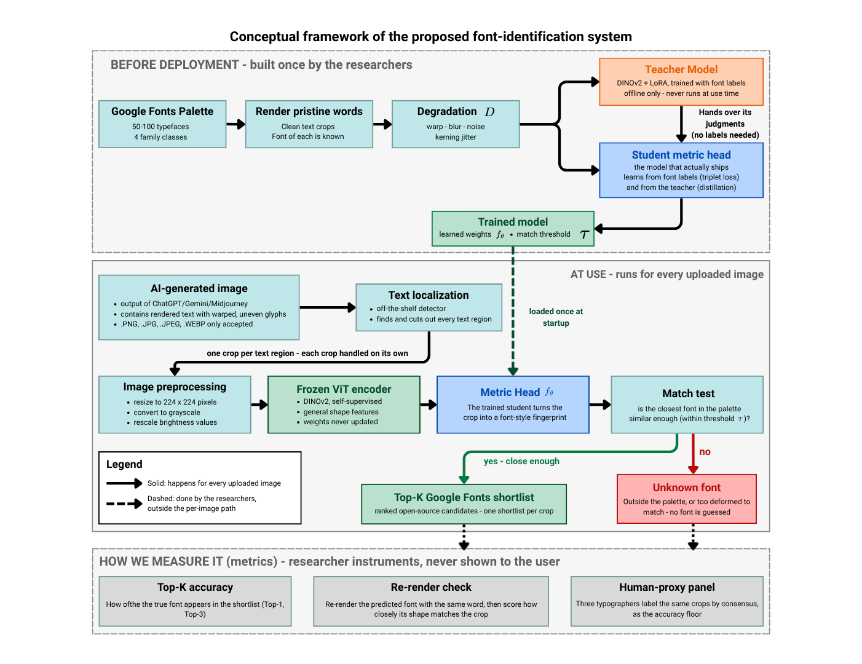
Conceptual Framework of the Proposed Font-Identification System
The figure is read through the line convention stated in its legend. Solid arrows mark the per-image path, meaning every step that executes when a designer submits an image. Dashed arrows mark researcher-side work that sits outside that path, covering both the preparation band above and the measurement band below. The two kinds of flow meet at exactly one point, where the trained model is loaded into the running system at startup, and that hand-off is drawn dashed because it precedes the per-image path rather than belonging to it. The localization step stays solid because it does execute live on every request, even though it is off-the-shelf and replaceable, which keeps the thesis focused on the recognition that follows it. Two absences in the figure are deliberate. The web application does not appear, because it is a delivery surface rather than a conceptual stage and is specified instead in the system architecture of Section 4.5.2. The measurement band is drawn outside the per-image path for the same reason the re-render check is not a runtime step: the structural comparison of Section 4.2.2 is a validation instrument the researchers apply to held-out data, and it neither re-ranks the shortlist nor reaches the designer. This separation is what lets the same model serve live requests while remaining fully reproducible from the researcher-controlled data pipeline.

4.4.3 Value Proposition
The design suits its problem for three reasons. It is open-set: unlike a closed-set classifier that must name some font for every input, it can refuse, which matters when many generative crops correspond to no real typeface. It is trained on the hallucination distribution itself rather than on pristine glyphs, so it does not collapse on the warped, re-kerned input that defeats commercial identifiers and clean-glyph baselines. And because it targets a localized open-source palette, every match it returns is immediately reusable at no cost, so recognition ends in a template the designer can rebuild from instead of a paywalled lookup.

4.4.4 High-Level Operational Logic
From the user’s side the interaction is simple. A designer opens the web application, uploads a generative-AI image containing text, and waits a moment while the system localizes and crops the text regions and runs each crop through the inference engine. For every detected region the application displays a short, ranked list of candidate Google Fonts, each shown as a rendered preview, or an “unknown” message when the system judges the glyph to fall outside its palette. The designer picks the closest match and reuses it directly in their own document. The user needs no knowledge of embeddings, thresholds, or the training pipeline; the technical machinery of Sections 4.2 and 4.3 stays hidden behind a single upload-and-review interaction.

4.5 Analysis and Design
This section turns the concept of Section 4.4 into a specification. Section 4.5.1 states what the system must do and the qualities it must have, scoped to a local testing deployment rather than a public service. Section 4.5.2 describes the architecture that satisfies those requirements and how its parts communicate.

4.5.1 Requirements Analysis
Functional requirements. The system must:
- Accept an uploaded generative-AI image in common raster formats (PNG, JPEG) through the browser.
- Localize and crop each text region in the image using an off-the-shelf text detector.
- Preprocess each crop and embed it with the frozen DINOv2 encoder and the trained metric head.
- Apply the open-set decision to each crop, either rejecting it as “unknown” or ranking the localized palette.
- Return, for every detected region, a Top-K shortlist of candidate Google Fonts or an “unknown” verdict.
- Render a preview of each candidate font so the user can compare it against the source text.
- Expose the recognition pipeline through a REST endpoint (/predict) that the frontend calls.
- Load the trained model weights once at startup and reuse them across requests.
Non-functional requirements. The system should also:
- Be usable through a single upload-and-review interaction that hides the underlying model (usability).
- Return results at interactive latency on a single machine, targeting a response within a few seconds per image (responsiveness).
- Produce the same output for the same input, through deterministic preprocessing and pinned model weights and seeds (reproducibility).
- Run from a single Docker image on one host, with no external service dependencies at inference time beyond the bundled weights and font files (portability).
- Keep the localizer, encoder, metric head, and open-set decision as separable components, so any one can be replaced without rewriting the others (maintainability).
- Operate as a single-user local demo, with no authentication, accounts, or multi-user scaling in scope (a deliberate delimitation, consistent with Section 4.1).
- Report an honest “unknown” rather than a forced guess when the open-set score falls below threshold (transparency).

4.5.2 System Architecture
The architecture is a layered client-server design, shown in Figure 9. It separates a thin presentation layer from a Python inference backend, and separates both from the model and font resources they depend on.
Figure 9
System Architecture of the Font-Identification Web Application
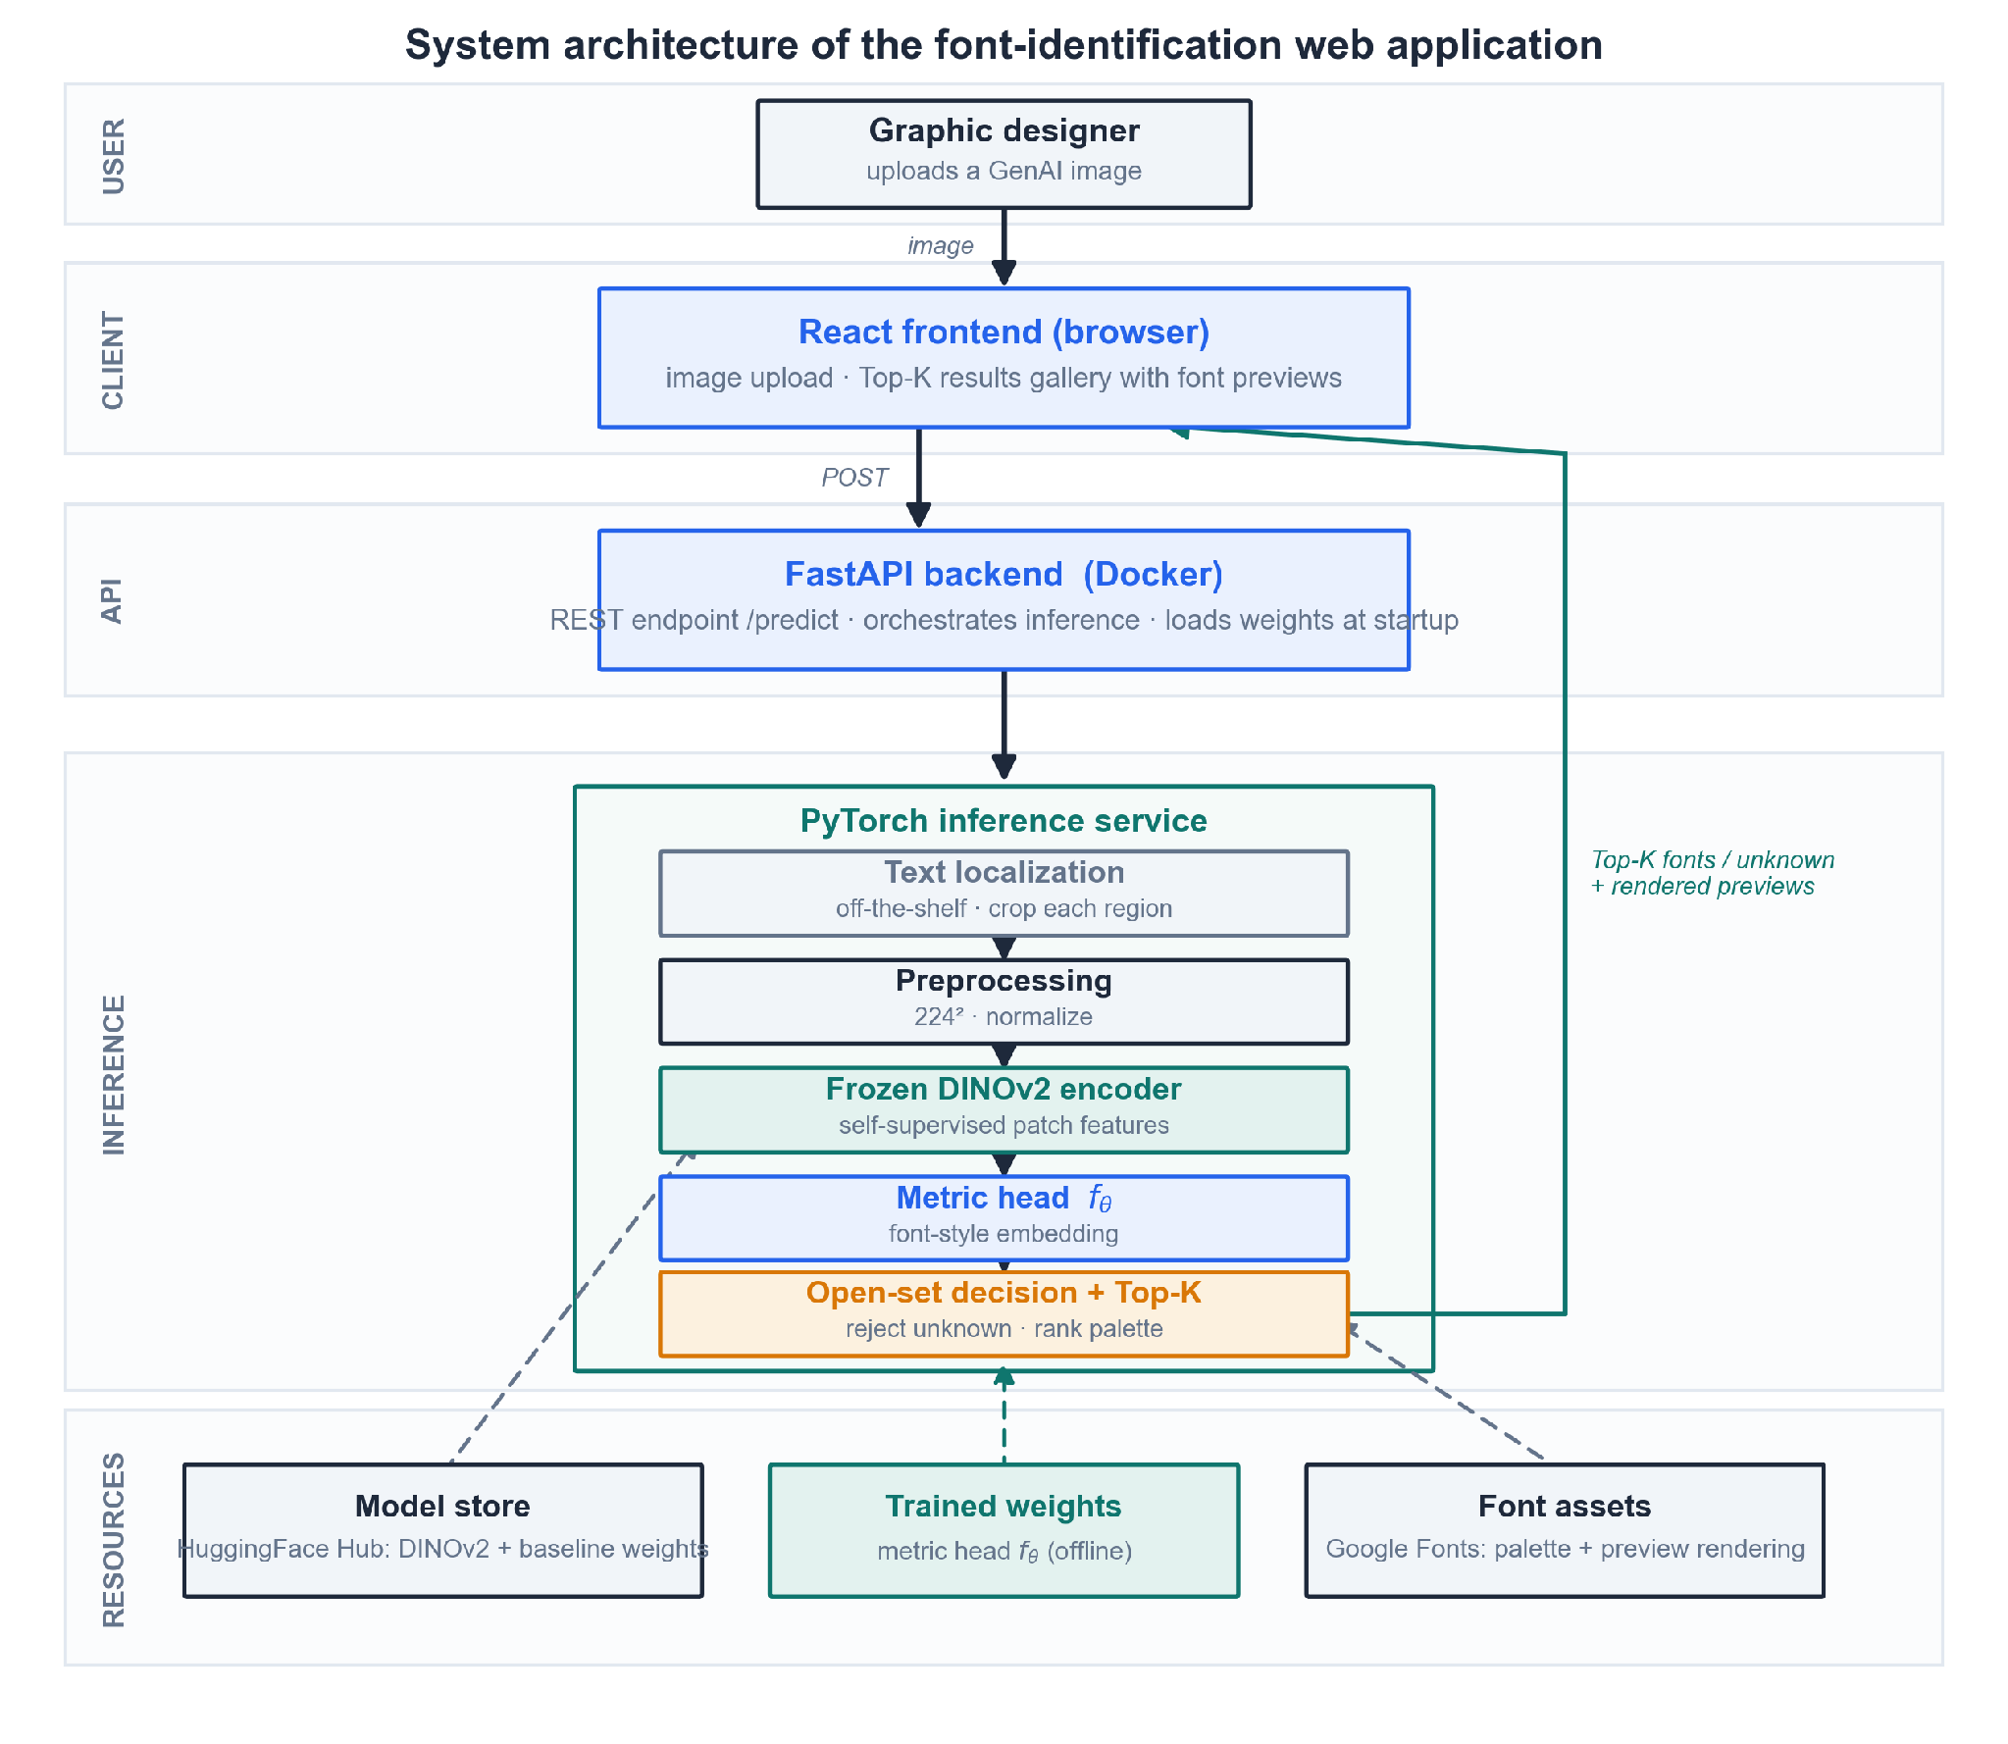
As shown in Figure 9, a request flows top to bottom and the result returns to the client. The client tier is a React single-page application in the browser: it handles the image upload and renders the Top-K results gallery with font previews. It calls the API tier, a FastAPI backend packaged in a Docker image, which exposes the /predict endpoint, orchestrates the inference call, and loads the model weights when it starts. The API hands each request to the inference tier, a PyTorch service that runs the pipeline of Section 4.4: off-the-shelf text localization, preprocessing, the frozen DINOv2 encoder, the metric head $f_{θ}$, and the open-set decision that produces a Top-K shortlist or an “unknown” verdict per crop. The resources tier holds what the inference tier reads but does not compute at request time: the DINOv2 backbone and baseline weights pulled from the HuggingFace Hub, the metric-head weights trained offline, and the Google Fonts files used both as the recognition palette and to render the candidate previews.
Two design choices in this layout matter for the rest of the chapter. First, the inference tier is the only stateful-at-startup component and the only one specific to this thesis; the localizer above it and the font assets beside it are replaceable off-the-shelf parts. Second, the offline training that produces the metric-head weights is not part of the request path at all. It runs separately and deposits weights into the resource tier, which keeps the served system reproducible from the researcher-controlled pipeline and lets the model be retrained or swapped without touching the API or the frontend.

4.6 Development Model

4.6.1 Identification of the Model
This study follows an iterative-incremental development model. The system is built as a sequence of increments, each of which runs a full Analyze, Design, Build, and Evaluate cycle and delivers a working slice that integrates into the growing whole. The model is shown in Figure 10.

4.6.2 Justification
The iterative-incremental model fits this project better than a single-pass model such as Waterfall for two reasons. First, the work is part research: the behavior of the metric embedding and the open-set threshold cannot be fully specified in advance, and each increment’s evaluation, such as Top-K accuracy or the rejection rate on held-out crops, feeds back into the design of the next. A model that froze the design before any results existed would not survive contact with the data. Second, the components have a natural build order and dependencies: the recognizer cannot be trained without the synthetic dataset, the open-set decision cannot be tuned without a trained embedding, and the web application only has something to serve once the recognizer works. Delivering these as increments keeps a working, testable artifact in hand at every stage and isolates risk to one increment at a time, which suits a two-person team without a dedicated QA role.

4.6.3 Phases of the Model
The project is organized into four increments, each producing a deliverable that the next increment consumes.
- Increment 1: Synthetic data pipeline. Analyze the documented deformation modes, design the rendering and degradation operator $D$, build the pipeline, and evaluate the crops against the target hallucination distribution. Deliverable: a labeled corpus of pristine and degraded crops (Section 4.3.1).
- Increment 2: Metric embedding. Design and build the frozen DINOv2 encoder with the trained metric head, and evaluate embedding separability across fonts and families. Deliverable: the frozen encoder plus the trained head $f_{θ}$ (Section 4.3.2).
- Increment 3: Open-set decision and evaluation. Add the rejection score, the calibrated Top-K, and the structural-distance verification, then evaluate against the baselines and the human-proxy panel. Deliverable: the full recognizer with its Top-K, rejection, and metric outputs (Sections 4.2 and 4.10).
- Increment 4: Web application. Wrap the recognizer in the FastAPI backend and React frontend, then evaluate it interactively on real uploaded images. Deliverable: the running demo application (Section 4.5).

4.6.4 SDLC Diagram
Figure 10
Iterative-Incremental Development Model
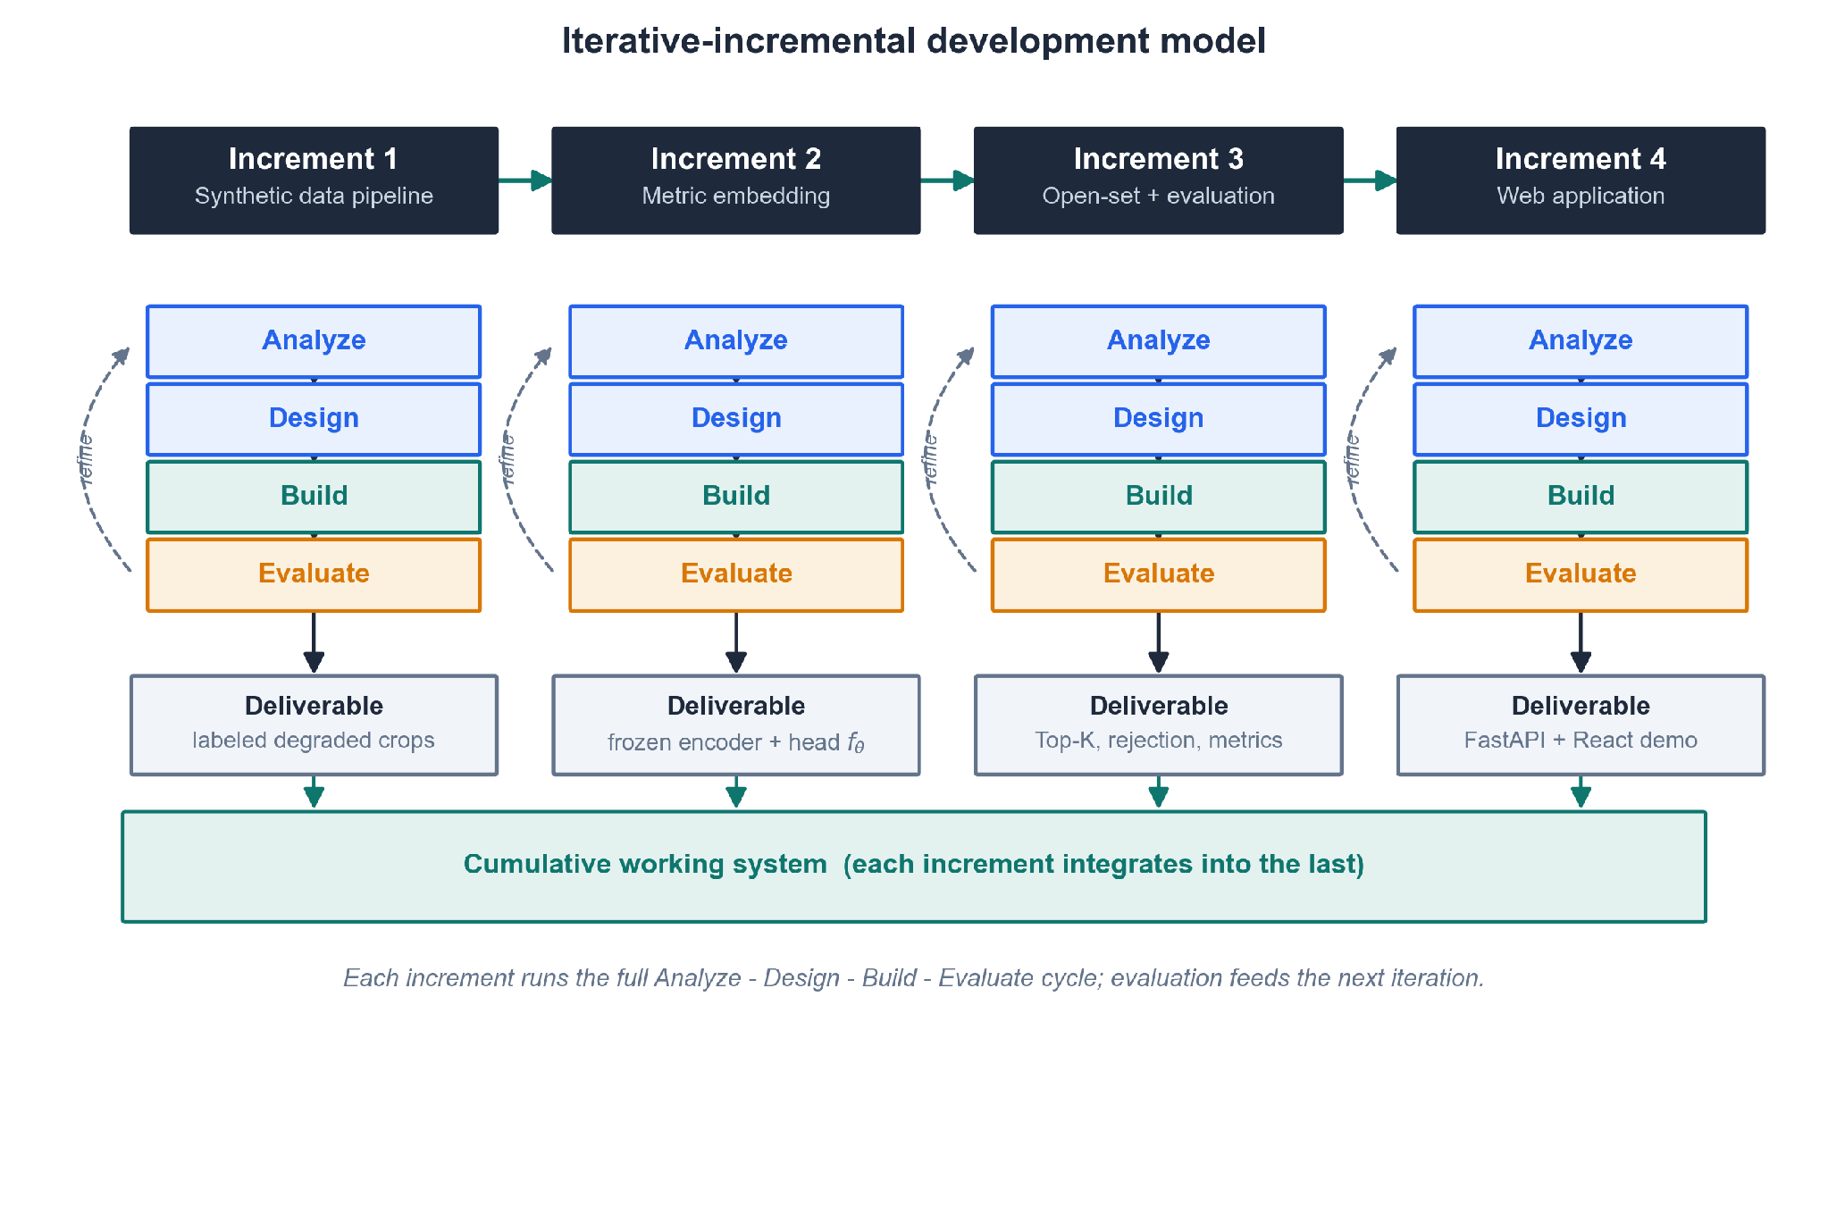
As shown in Figure 10, the four increments proceed left to right, but the arrows within each increment show that development is not linear inside it: the Analyze, Design, Build, and Evaluate phases repeat, and each evaluation refines the same increment before the next one begins. The deliverables accumulate into a single working system rather than being integrated only at the end, so that a failure surfaced late, for example an open-set threshold that rejects too many valid crops, can be traced to the increment that introduced it.

4.7 Development Approach

4.7.1 Bottom-Up Construction
The system is built bottom-up. Construction starts at the data and model layers and works upward to the interface, in the increment order of Section 4.6: the synthetic data pipeline first, then the metric embedding, then the open-set decision and evaluation, and only last the web application that presents them. This direction follows the dependency structure of the problem, since each layer is useless to test until the one beneath it works, and it matches the runtime-versus-offline split of Figure 8, in which the offline pipeline produces trained weights that the served system later loads. A top-down approach, starting from the user interface and stubbing the model, would have deferred the project’s central research risk (whether a deformation-robust open-set recognizer is achievable at all) until after the surface was built, which is the opposite of what the schedule can afford.

4.7.2 Architectural Patterns
The build organizes around a few standard patterns. The application is a layered client-server system with a clear separation of concerns: presentation in the React client, request handling in the FastAPI service, and recognition in the PyTorch inference tier (Section 4.5.2). The client and server communicate over a REST interface, which keeps the frontend independent of the model internals and lets either side be developed against a fixed contract. The recognizer itself is a modular pipeline, in which text localization, preprocessing, encoding, the metric head, and the open-set decision are separate stages with defined inputs and outputs, so that a stage can be replaced, for instance swapping the off-the-shelf localizer, without disturbing the others. Inference is stateless across requests: the model weights load once at startup and each request is handled independently, which keeps the served component simple and reproducible.

4.7.3 Coding Philosophy
Three principles guide how the code is written. The first is reproducibility: random seeds, pinned dependency versions, and fixed model weights are recorded so that a run can be regenerated, and the preprocessing transforms are embedded in the model’s forward pass so that training and serving apply identical steps and no train-serve skew can creep in (Section 4.3.2). The second is reuse over reinvention: the backbone (DINOv2), the baseline classifiers, and the text localizer are taken off the shelf rather than rebuilt, so that effort concentrates on the thesis’s actual contribution, the deformation-robust open-set recognizer. The third is configuration over hard-coding: the palette size, degradation parameters, Top-K value, and rejection threshold are treated as configurable settings rather than constants buried in the code, which is what makes the iterative evaluation of Section 4.6 practical, since each increment can re-tune these without a rewrite.

4.8 Software Development and Tools
The stack is chosen against a few criteria: every tool is free and open-source, so the system can be replicated at no licensing cost, which is consistent with the free-reconstruction goal of the study; each is mature and widely supported, so documentation and community help are available; and each is the standard choice in its layer, which keeps the learning curve low for a two-person team. Because the served system is stateless and persists nothing between requests (Section 4.7.2), no database is used, so the database-connectivity criterion does not apply. Table 2 lists the tools by function, with the version used and an access link; the role each tool plays is discussed below the table.
Table 2
Software and Tools Used in the Development of the System
Function | Tool | Version | Access link
Language and model | Python | 3.13 | https://www.python.org
Language and model | PyTorch | 2.6 | https://pytorch.org
Language and model | Hugging Face Transformers | 4.49 | https://github.com/huggingface/transformers
Language and model | Hugging Face Hub | 0.28 | https://huggingface.co
Language and model | NumPy | 2.2 | https://numpy.org
Language and model | scikit-learn | 1.6 | https://scikit-learn.org
Data and rendering | Pillow (PIL) | 11.1 | https://python-pillow.org
Data and rendering | OpenCV | 4.11 | https://opencv.org
Data and rendering | EasyOCR | 1.7 | https://github.com/JaidedAI/EasyOCR
Backend | FastAPI | 0.115 | https://fastapi.tiangolo.com
Backend | Uvicorn | 0.34 | https://www.uvicorn.org
Backend | Pydantic | 2.10 | https://docs.pydantic.dev
Frontend | React | 19 | https://react.dev
Frontend | Vite | 6 | https://vite.dev
Frontend | Node.js | 22 LTS | https://nodejs.org
Deployment | Docker | 27 | https://www.docker.com
Version control | Git | 2.47 | https://git-scm.com
Version control | GitHub | (web service) | https://github.com
Documentation | Matplotlib | 3.10 | https://matplotlib.org
Documentation | Pandoc | 3.10 | https://pandoc.org
Documentation | Visual Studio Code | 1.98 | https://code.visualstudio.com
Note. Versions are current as of July 2026 and are pinned in the project’s dependency lockfiles; a replicator should confirm the latest compatible releases at the time of setup. All tools are open-source and free to use; the hosted collaboration service (GitHub) offers a no-cost tier sufficient for this project.
In the language-and-model layer, Python is the primary language for the data pipeline, the model, and the backend, with PyTorch as the deep-learning framework for the encoder, the metric head, and training. Hugging Face Transformers loads the DINOv2 backbone and the baseline classifiers, the Hugging Face Hub pulls pre-trained weights and stores the trained metric head, NumPy carries the array and numerical operations, and scikit-learn supplies the evaluation metrics, the stratified k-fold split, and the confusion matrix. In data and rendering, Pillow renders font specimens into word-crop images, OpenCV applies the elastic warp and the other degradation operations, and EasyOCR performs the off-the-shelf text localization and cropping. The backend exposes inference through FastAPI’s /predict REST endpoint, served by the Uvicorn ASGI server, with Pydantic validating request and response schemas; the frontend is a React interface for image upload and the results gallery, built by Vite on the Node.js runtime. Docker containerizes the backend for reproducible deployment, Git and GitHub provide version control and repository hosting, and the documentation toolchain uses Matplotlib to generate the thesis figures, Pandoc to export the Markdown chapters to DOCX, and Visual Studio Code as the primary editor.

4.9 Project Management

4.9.1 Schedule and Timeline
The project runs from June to December 2026. The schedule follows the increment order of Section 4.6, with the written chapters interleaved so that each empirical chapter is drafted as its results become available. Figure 11 shows the plan as a Gantt chart. As of the reporting date (July 10, 2026), Chapters 2 and 3 are complete and Chapter 4 is in progress; the four development increments, the results and conclusion chapters, and the final revisions follow through December.
Figure 11
Project Schedule and Timeline (June to December 2026)

As shown in Figure 11, the early months cover the written groundwork (Chapters 2 and 3), the middle months carry the build increments from the synthetic data pipeline through the web application, and the final months are reserved for the results and conclusion chapters and for revision ahead of the defense. The development increments overlap the empirical chapters deliberately, because Chapter 5 reports the evaluation that increment 3 produces.

4.9.2 Responsibilities
The study is carried out by two researchers, both of whom act as researcher and developer. Table 3 divides the work. The split follows the two sides of the system: one member owns the Python model and data side, the other owns the service and interface side, and the writing is shared with cross-review.
Table 3
Division of Responsibilities
Member | Responsibilities
Janritch Diputado | Python scripting: synthetic data pipeline, model training, and the inference engine. Lead author of Chapter 2 (Review of Related Literature) and Chapter 3 (Technical Background).
Matt Cabarrubias | Backend REST API (FastAPI) and the React frontend web application. Lead author of Chapter 4 (Methodology); contributor and reviewer for Chapters 2 and 3.
Both (shared) | System design, integration, evaluation and human-proxy panel coordination, and preparation for the final defense.
Note. Authorship is stated by lead contributor; both members reviewed and contributed to all chapters.

4.9.3 Budget and Cost Management
The budget below estimates what it would cost another researcher or organization to replicate this study, not only the out-of-pocket cost to the current team. It therefore includes labor, since replication effort is the largest real cost, alongside compute, utilities, documentation, and contingency. Because the entire software stack is open-source (Section 4.8), the study carries no mandatory license or subscription cost, which is a deliberate outcome of the free-reconstruction design. Table 4 lists the estimate.
Table 4
Estimated Replication Budget
Category | Item | Basis / assumption | Amount (PHP)
Labor | 2 researcher-developers | ~30 weeks × ~15 hr/week each ≈ 900 hours total, at an illustrative ₱250/hr | 225,000
Compute | Cloud GPU for training and experiments | ~100 to 150 GPU-hours; the backbone is frozen and only the metric head trains | 5,000
Subscriptions | Software stack | Fully open-source; none required | 0
Data storage | Synthetic dataset | Generated locally (a few GB); no paid storage | 0
Utilities | Internet and electricity | ~₱1,500/month × 7 months, shared | 10,500
Documentation | Hard-bound thesis copies | ~₱1,500 × 3 copies | 4,500
Contingency | Overhead on non-labor items | ~10% | 2,000
Total (with labor) |  | Full replication cost | ~247,000
Total (materials only) |  | If replicated by unpaid students | ~22,000
Note. Figures are planning estimates, not incurred expenses. The labor line dominates and is the most adjustable: it scales with the hourly rate and with how much of the pipeline a replicator reuses from the released code. The materials-only total reflects the near-zero software cost that the open-source stack makes possible.

4.10 Verification, Validation and Testing
This section describes how the study checks its own work along three axes: verification asks whether the system is built correctly, validation asks whether the correct system was built (whether it meets the objectives of Section 1.2), and testing asks whether the software runs without errors. The study uses a combined build method and model method: the build method delivers the working artifacts (the recognizer and the web application) as evidence that the approach is realizable, while the model method evaluates an abstract model of the system through quantitative metrics on held-out data, which allows controlled measurement that the deployed application alone could not provide.

4.10.1 Verification: Building the System Right
Verification targets the internal correctness of each component. The pipeline stages of Section 4.4 (localization wrapper, preprocessing, encoder, metric head, and open-set decision) are checked with unit and integration tests that confirm each stage produces the expected shape and range of output and that the stages compose end to end. Reproducibility is verified directly: because random seeds, dependency versions, and model weights are pinned (Section 4.7.3), a fixed input must regenerate a bit-identical dataset and the same prediction on re-run, and the preprocessing-in-forward design is verified by confirming that the training-time and inference-time transforms produce identical tensors for the same crop, so no train-serve skew is present. Because the team has no separate QA role, the two members cross-review each other’s code, which is the verification pass on the parts each did not write.

4.10.2 Validation: Building the Right System
Validation asks whether the system meets the specific objectives of Section 1.2.3, and it is where the study’s quantitative and qualitative measures are applied. Each objective maps to a measure.
For the recognition objective, the system is scored under the Top-1 and Top-3 accuracy protocol that DeepFont established as the field standard (Wang et al., 2015), on both the held-out synthetic test partition and the separate real-generative test set. For the open-set objective, rejection quality is measured by the true-positive and false-positive rates at the operating threshold, reported as the false-positive rate at 95% recall so that the fraction of out-of-palette crops wrongly accepted is explicit. For the verification-of-prediction objective, each predicted font is re-rendered and scored against the input crop with a deformation-robust structural distance (Zhang et al., 2024), and the error distribution is analyzed by typographic family through a confusion matrix and weighted by the embedding-centroid severity index, so that within-family errors are distinguished from more damaging cross-family ones (Chen et al., 2026). The calibrated Top-K shortlist is validated by its empirical coverage against the conformal guarantee it claims (Ding et al., 2025; Shi et al., 2024).
Validation is also comparative and human-anchored. The system is benchmarked against two closed-set baselines, the Storia-AI Google Font Classifier (Jiang et al., 2025) and the DINOv2-LoRA model of Chen et al. (2026), both run on the same real-generative crops, to quantify how much the open-set, deformation-trained approach recovers where pristine-trained baselines collapse. The ground truth for those crops is set by a three-person expert human-proxy panel (Section 4.2.3): each rater independently assigns a palette font or an “unknown” verdict to each of the [N = 100] real generative text boxes, a label is fixed by agreement of at least two of three, and rater agreement is reported as a Fleiss’ $κ$ of [κ = X.XX]. The panel provides both the accuracy floor for the comparison and an independent, qualitative estimate of how often genuine typographic ambiguity occurs in uncorrected generative output.

4.10.3 Testing: Confirming the System Works
Testing confirms that the delivered software behaves correctly under normal and abnormal use. The web application is exercised end to end: an uploaded image must return a per-region Top-K shortlist or an “unknown” verdict with font previews, and the /predict endpoint is checked against its request and response contract. The responsiveness requirement of Section 4.5.1 is tested by measuring per-image latency against the interactive target. Error handling is tested with abnormal inputs, including unsupported file types, images with no detectable text, and crops the recognizer rejects as unknown, to confirm the system fails gracefully rather than crashing. Passing these tests, together with the verification and validation results above, is the evidence that the artifact both works and answers the research questions of Section 1.2.

APPENDIX A

SOFTWARE REQUIREMENTS SPECIFICATION

IEEE 830 / ISO·IEC·IEEE 29148 Format

Addressing Typographic Hallucination in Generative AI Images: An Open-Set Metric Learning Approach to Font Style Recognition
Version 1.1 · July 26, 2026

By
Janritch Diputado
Matt Cabarrubias

Christine D. Bandalan, MEng
Faculty Adviser

Revision History
Date | Version | Description | Author
2026-07-16 | 1.0 | Initial thesis-scoped SRS | Research team
2026-07-26 | 1.1 | Restructured to the IEEE 830 capstone template; adviser format revisions | Research team

1. Introduction

1.1 Purpose
This Software Requirements Specification (SRS) defines the functional and non-functional requirements for FontID version 1.x, the web demonstrator that exposes the thesis’s font-recognition model to a user. It is the artifact half of the study’s build method (Ch4 §4.10): a single-page application that accepts a generative-AI image, runs the open-set metric-learning pipeline, and returns a ranked shortlist of the closest Google Fonts for each detected line of text — or rejects the text as out-of-palette. The software will not perform font vectorization, licensing, or any commercial identification.

1.2 Document Conventions
Each requirement is labeled REQ-<section>-<n> (e.g., REQ-4.1-2) with priority High / Med / Low. Mandatory behavior uses shall; desired behavior uses should. Tables and figures follow APA 7th edition formatting.

1.3 Intended Audience and Reading Suggestions
The document is intended for the two researcher-developers, the faculty adviser, and the panel evaluating the demonstrator. The panel and adviser may read Section 2 for a high-level view of scope and functions; the developers should read Sections 3–5 in full; evaluators verifying the demo should focus on Section 4 (features) and Section 5 (non-functional requirements) to derive test cases.

1.4 Product Scope
FontID is a local demonstration harness, not a production service. It wraps the trained model so that hallucinated text crops map to a localized palette of the top 50–100 Google Fonts for free template reconstruction. Explicitly out of scope: user accounts, multi-user scaling, persistent storage, payment/licensing, and font vectorization. The app is single-page with three zones — Input → Processing → Results — and runs on one machine for the defense demo.

1.5 References
Ref# | Document Title | Version/Date | Source
[1] | Thesis Chapter 4 — Methodology (conceptual framework §4.4, architecture §4.5, build method §4.10) | 2026 | This thesis
[2] | IEEE Std 830-1998, Recommended Practice for Software Requirements Specifications | 1998 | IEEE
[3] | ISO/IEC/IEEE 29148:2018, Requirements engineering | 2018 | ISO/IEC/IEEE
[4] | Google Fonts open-source font library | current | https://fonts.google.com

2. Overall Description

2.1 Product Perspective
FontID is a new, self-contained front end over an existing trained model; it adds no new learning logic. The runtime path is layered — React client → FastAPI backend → PyTorch inference service → model weights and font assets — as detailed in the system-architecture diagram (Ch4 §4.5.2, Fig 9). The trained metric head is produced offline; the app only loads and serves it.

2.2 Product Functions
- Accept a GenAI image by drag-drop, file browse, or a bundled sample — drawn from a pool of at least 10 real AI-generated demo images, never part of any training data, with 3 offered at random each start-up.
- Localize the text region(s) in the image and crop each one.
- Embed each crop and rank it against the font palette.
- Return a Top-K shortlist per crop with a similarity score, or reject it as out-of-palette.
- Render each candidate font as a live preview of the detected text for visual confirmation.

2.3 User Classes and Characteristics
User class | Characteristics | Privileges/Access
Designer / end user | Non-technical; wants a free font match to rebuild a template. | Standard access: uploads an image, reads the Top-K shortlist.
Researcher / evaluator | The team + panel; technical. | Full local access: drives the demo, inspects backend score/τ logs, confirms open-set reject behavior.

2.4 Operating Environment
- Client: current Chrome / Firefox / Edge (latest two versions), desktop viewport.
- Server: Python 3.11+, FastAPI, PyTorch, packaged with Docker; runs on the presenter’s laptop (localhost). GPU optional — CPU inference acceptable for single-image demo latency.
- Assets: DINOv2 + baseline weights from HuggingFace Hub; Google Fonts files for palette matching and preview rendering.

2.5 Design and Implementation Constraints
- Stack is fixed by the methodology (Ch4 §4.8): React (frontend), FastAPI (backend), PyTorch + HuggingFace (inference), Docker (deploy).
- Preprocessing (square-pad → 224² → ImageNet normalize) shall run inside the model forward pass to avoid train–serve skew (Ch4 §4.3.2).
- Only open-source fonts (the Google Fonts palette) may be returned — no commercial font identifiers or licenses.

2.6 Assumptions and Dependencies
- The trained metric head and palette are available on disk at startup.
- The uploaded image contains legible rendered text (not handwriting / heavy occlusion).
- The off-the-shelf text-localization component is available and returns bounding boxes.
- The HuggingFace Hub remains reachable for the one-time weight download; after that the app runs offline.

3. External Interface Requirements

3.1 User Interfaces
Single page, three vertically stacked zones (wireframe below):
- Input — a drag-drop/browse dropzone, sample thumbnails, and an Identify Fonts action.
- Processing — the uploaded image with detected text regions boxed, plus a pipeline status/progress indicator.
- Results — a carousel showing one card at a time per detected crop, navigated with previous/next arrows, a region indicator (“Region 1 of 2”), and pagination dots. Each card holds the crop thumbnail, its Top-K font shortlist (name · preview · similarity bar), and a KNOWN / UNKNOWN badge for the open-set decision.
The interface shall work at desktop widths and keep all three zones reachable on one page. Standard affordances: every result font preview offers a copy-name / preview action.
Figure A1
FontID Single-Page Wireframe (Input → Processing → Results)
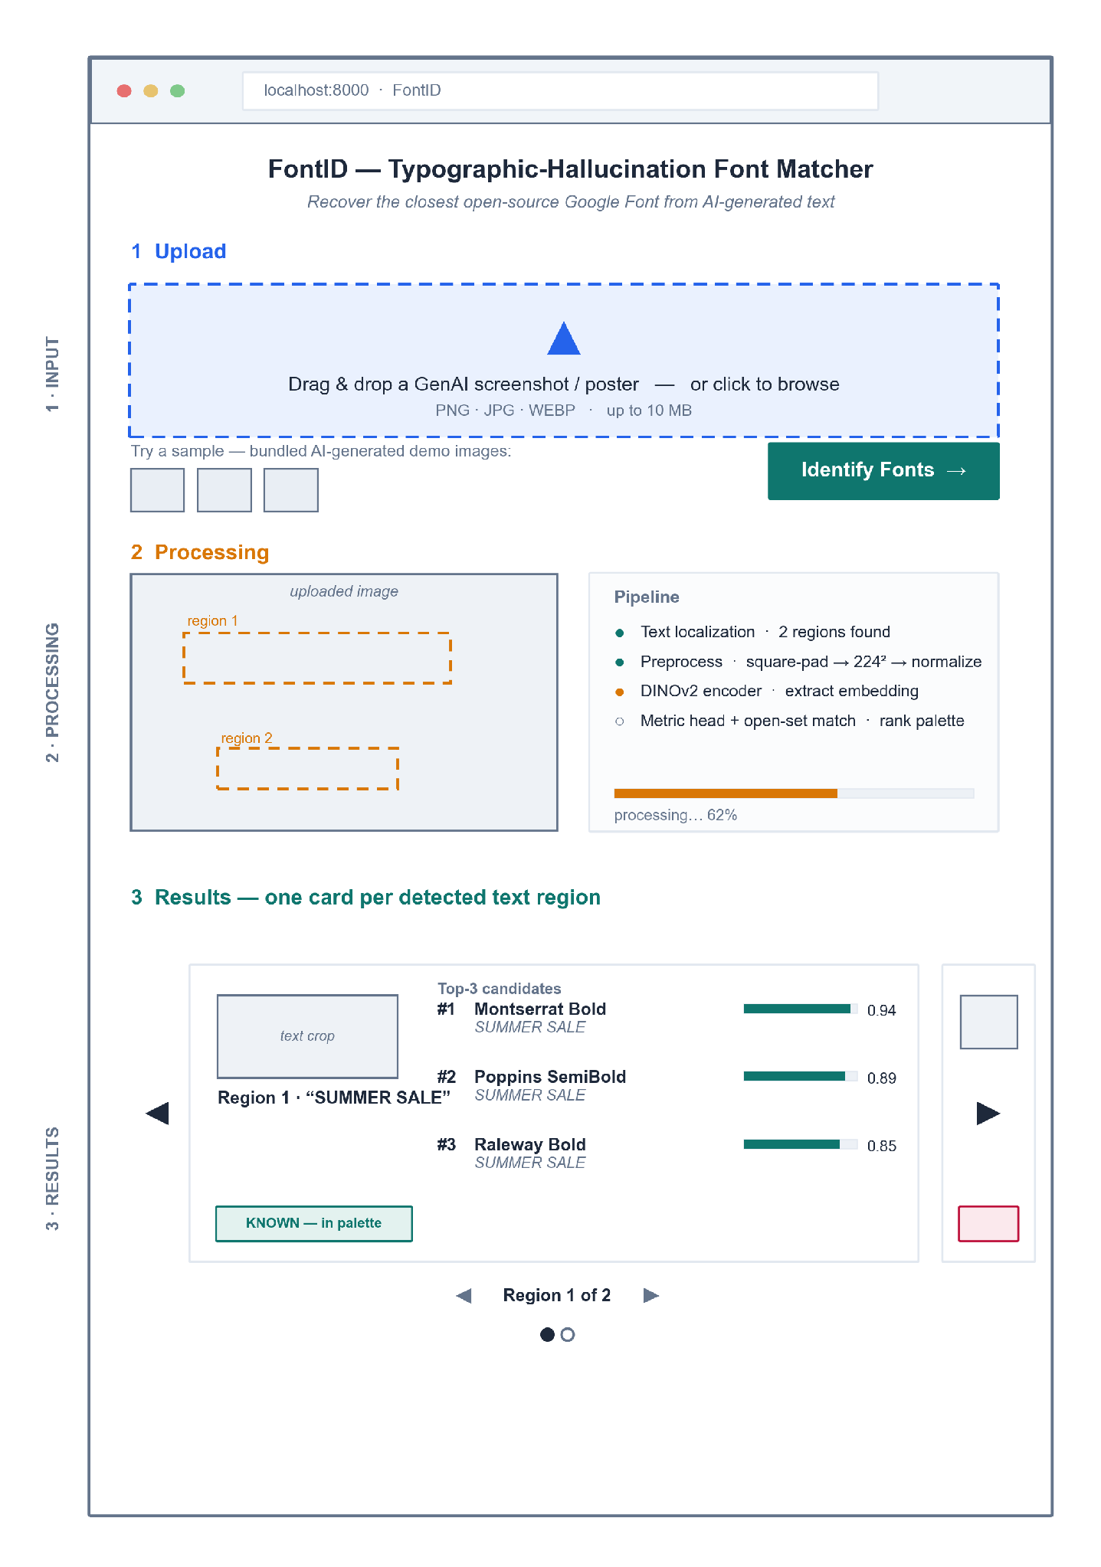
Figure A1 shows a three-zone single page. Results are a carousel, one card per detected region: Region 1 accepts (Top-3 in palette); Region 2, reached with the next arrow, is rejected as out-of-palette (max similarity < τ), demonstrating open-set behavior.

3.2 Hardware Interfaces
No dedicated hardware interface exists. The system runs on a commodity laptop; an NVIDIA GPU, when present, is used through the standard CUDA driver stack, and CPU-only operation is supported. No scanners, sensors, or printers are involved.

3.3 Software Interfaces
Interface | Purpose | Data exchanged
POST /predict (FastAPI REST) | Client sends the image; server returns results. | Request: image (multipart). Response: JSON — per crop, bounding box + Top-K {font, score} + known flag.
HuggingFace Hub | Load DINOv2 + baseline weights at startup. | Model tensors (read-once).
Google Fonts assets | Palette matching + preview rendering of candidate fonts. | Font files (.ttf/.woff2).

3.4 Communications Interfaces
All client–server traffic is HTTP over localhost (REST, JSON, multipart upload). No external network traffic occurs at request time, no email or notification channels exist, and no TLS is required for the single-machine demo.

4. System Features

4.1 Image Input

4.1.1 Description and Priority
User supplies a GenAI image by drag-drop, file browse, or a bundled sample. Priority: High.

4.1.2 Stimulus/Response Sequences
User drops/selects an image → client shows a preview and enables Identify Fonts → click posts the image to /predict.

4.1.3 Functional Requirements
ID | Requirement Description | Priority
REQ-4.1-1 | The system shall accept an image via drag-drop, file picker, or a bundled sample. | High
REQ-4.1-2 | The system shall accept raster images in PNG (.png), JPEG (.jpg, .jpeg), and WebP (.webp) up to 10 MB, and reject any other type (e.g., SVG, GIF, HEIC, TIFF) with a clear message. | High
REQ-4.1-3 | The system shall display a preview of the uploaded image before processing. | Med
REQ-4.1-4 | The app shall bundle a pool of at least 10 real AI-generated sample images (e.g., DALL·E, Midjourney, Stable Diffusion output), none part of any training data; the samples offered shall be randomly selected from this pool at each start-up, and the interface shall label their origin. | Med

4.2 Text Localization and Processing

4.2.1 Description and Priority
The backend finds text regions and prepares each crop for matching. Priority: High.

4.2.2 Stimulus/Response Sequences
/predict receives the image → localizer returns bounding boxes → each crop is preprocessed and embedded → status advances in the Processing zone.

4.2.3 Functional Requirements
ID | Requirement Description | Priority
REQ-4.2-1 | The system shall detect one or more text regions and crop each region for independent matching. | High
REQ-4.2-2 | The system shall preprocess each crop (square-pad → 224² → normalize) inside the model forward pass. | High
REQ-4.2-3 | The system shall show processing status/progress and detected-region boxes while inference runs. | Med
REQ-4.2-4 | The system should return an informative error if no text region is found. | Med

4.3 Font Matching and Top-K Results

4.3.1 Description and Priority
For each crop, the system ranks the palette and decides known vs. unknown. Priority: High.

4.3.2 Stimulus/Response Sequences
Embedding is compared to the palette → if best similarity ≥ τ, return the ranked Top-K; else mark the crop out-of-palette.

4.3.3 Functional Requirements
ID | Requirement Description | Priority
REQ-4.3-1 | The system shall return a Top-K (K = 3) ranked shortlist of Google Fonts per crop, each with a similarity score. | High
REQ-4.3-2 | The system shall reject a crop as “unknown / out-of-palette” when its best similarity falls below threshold τ (open-set). | High
REQ-4.3-3 | The system shall present each crop’s result as its own card in a carousel with previous/next navigation and a region indicator (e.g., “Region 1 of 2”), each card labeled KNOWN or UNKNOWN. | High
REQ-4.3-4 | The system should report a typographic-distance (SSIM) score between the crop and the top match. | Low
REQ-4.3-5 | The backend should log each crop’s similarity scores and its threshold (τ) decision for researcher analysis; these diagnostics are not shown in the user interface. | Low

4.4 Font Preview

4.4.1 Description and Priority
The user visually confirms a match against live-rendered candidates. Priority: Med.

4.4.2 Stimulus/Response Sequences
For each candidate font, the app renders the detected text string in that font beside the crop.

4.4.3 Functional Requirements
ID | Requirement Description | Priority
REQ-4.4-1 | The system shall render each shortlisted font as a live preview of the detected text. | Med
REQ-4.4-2 | The system should let the user copy a candidate font’s name for reuse. | Low

5. Other Nonfunctional Requirements

5.1 Performance Requirements
ID | Requirement Description | Priority
REQ-5.1-1 | The system shall return results for a single-image, ≤5-region upload within ~10 s on the demo laptop (CPU acceptable). | High
REQ-5.1-2 | Model weights shall load once at startup, not per request. | High

5.2 Safety Requirements
The system controls no physical process, so no physical-safety hazards exist. Against data loss: uploaded images are processed in memory and never written to disk, so a crash can lose at most the in-flight request; model weights and font assets are read-only at runtime.
ID | Requirement Description | Priority
REQ-5.2-1 | The system shall open model weights and font assets read-only at runtime, so a failed request cannot corrupt them. | Med

5.3 Security Requirements
As a single-user local demo the app has no authentication and no persistence; no personal data is collected, so no retention obligations arise under data-privacy regulation.
ID | Requirement Description | Priority
REQ-5.3-1 | The system shall process uploads in memory and discard them when the request completes; no upload shall be stored beyond the request lifetime. | High
REQ-5.3-2 | The server shall bind only to the localhost interface and accept no remote connections. | Med

5.4 Software Quality Attributes
ID | Requirement Description | Priority
REQ-5.4-1 | Usability: a first-time user shall complete upload → results without instructions, in one page with no navigation. | High
REQ-5.4-2 | Usability: scores and known/unknown status shall be visible without interaction. | Med
REQ-5.4-3 | Reliability: the system shall handle an unreadable/oversized/textless upload without crashing, returning a clear message. | High
REQ-5.4-4 | Portability: the system shall run from a single Docker image on a clean machine with no manual dependency setup. | Med

5.5 Business Rules
- Only fonts from the open-source Google Fonts palette may be named in a result; the system never identifies or recommends a commercial font.
- A crop whose best similarity falls below τ must be reported as unknown; the system never forces a closed-set label onto an out-of-palette crop.
- Bundled sample images must come from real generative-AI output and must never overlap any training data.

6. Other Requirements
- Licensing: every runtime component and font asset is open-source; the system shall carry no mandatory license or subscription cost.
- Data retention: none — the system stores no user data (see REQ-5.3-1).
- Internationalization: the interface is English-only; the recognition palette is limited to Latin-script fonts, matching the thesis scope.

Appendix A1: Glossary
Term | Definition
Typographic hallucination | Probabilistic glyph deformation (warping, kerning jitter, smear) that GenAI introduces into rendered text.
Palette | The curated closed set of 50–100 known Google Fonts the model can name.
Open-set / reject | Returning “unknown” when a crop’s best match falls below threshold τ, instead of forcing a wrong label.
Top-K | The K highest-ranked font candidates for one text crop (K = 3 in the demo).
Embedding | The fixed-length style vector produced by the DINOv2 encoder + metric head.
SSIM | Structural Similarity Index — re-render score between the input crop and the predicted font.

Appendix A2: Analysis Models
The analysis models for this system live in Chapter 4 and are not duplicated here: the conceptual framework (Fig 8, §4.4.2) models the offline-training versus at-use data flow, the system-architecture diagram (Fig 9, §4.5.2) models the layered client-server structure, and the iterative-incremental SDLC model (Fig 10, §4.6) models the build sequence.
Traceability. System features 4.1–4.4 realize the §4.5.1 functional requirements (upload · isolate crop · Top-K or unknown · font preview) and are served by the §4.5.2 architecture (Fig 9). Zones in the §3.1 wireframe map one-to-one to features 4.1 (Input), 4.2 (Processing), and 4.3–4.4 (Results).

APPENDIX B

EXPERT-PANEL RATING FORM
This appendix reproduces the layout of the web-based rating form that delivers the human-proxy consensus instrument of Section 4.2.3. The form has two screens. Screen A is shown once: it states the task, the ground rules (independent, self-paced, blind to the model’s predictions and to the other raters), and the palette reference sheet the rater keeps open while rating. Screen B repeats for each of the [N = 100] real generative text crops: the crop is displayed beside an excerpt of the reference sheet, and the rater makes exactly one required choice — the closest palette font, found through a searchable list, or the “Unknown / hallucinated” verdict when no palette font matches.
The layout is platform-neutral: it specifies the content and controls of each screen, not a hosting service, so any standard web-form platform can deliver it without altering the instrument. The item texts shown (crop wording, specimen names, item counter) are illustrative.
Figure B1
Expert-Panel Rating Form — Instructions Screen and Per-Crop Rating Item

Per-item responses save individually, so a rater may pause and resume without loss; each rater submits one complete response set, and the three sets are combined under the 2-of-3 consensus rule of Section 4.2.3.




July 23, 2026

Mark Joeneil Salas
Web Developer, Graphic designer
Engin8 Department

Dear Mr. Salas,

Greetings!

We respectfully request your participation as an expert evaluator and consultant for our thesis project entitled "Addressing Typographic Hallucination in Generative AI Images: An Open-Set Metric Learning Approach to Font Style Recognition." Generative AI image tools (e.g., DALL·E, Midjourney) render text with typographic hallucinations (warped glyphs, irregular kerning, and character smearing) that cause commercial font identifiers to fail. Our system applies a deep-learning metric-learning pipeline that matches such distorted text to the closest open-source Google Font, so that a designer can rebuild the typography from a free, license-clear font.
Given your expertise in graphic design, we specifically seek your help with the following:
- Serving on our expert-evaluation panel. You would visually identify and rank the closest matching Google Font for a curated set of approximately 100 AI-generated text samples. This expert consensus establishes the human ground-truth benchmark against which we measure our system's accuracy.
- Validating our research instrument. You would review our curated palette of the top 50 to 100 Google Fonts and the realism of our synthetic text-degradation samples.
Your involvement would take approximately 2-3 hours and would be conducted entirely online and asynchronously: you would complete a self-paced web-based rating form at your own convenience, with no scheduled session required. All responses will be used solely for academic purposes and reported in aggregate.
This research study is being conducted as part of the requirements for the completion of the Bachelor of Science in Computer Science program under the Department of Computer and Information Sciences and Mathematics, University of San Carlos. We believe that the findings of this study will contribute meaningfully to the advancement of knowledge and provide benefits to the community.

We sincerely appreciate your time and consideration, and we look forward to your positive response.

Thank you very much.

Respectfully,




Janritch D. Diputado Matt Erron G. Cabarrubias
Student Researcher Student Researcher

Noted by:

Christine D. Bandalan, MEng
Thesis Project Adviser

Approved by:
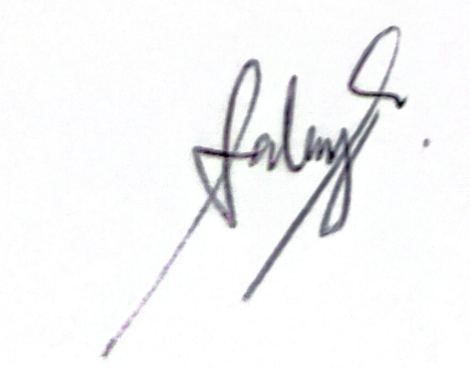

Mark Joeneil Salas
Web Developer, Graphic designer

July 23, 2026

Vincent Stephene Entoma
Graphic Designer, Team Leader
Seller Investigators Department

Dear Mr. Entoma,

Greetings!

We respectfully request your participation as an expert evaluator and consultant for our thesis project entitled "Addressing Typographic Hallucination in Generative AI Images: An Open-Set Metric Learning Approach to Font Style Recognition." Generative AI image tools (e.g., DALL·E, Midjourney) render text with typographic hallucinations (warped glyphs, irregular kerning, and character smearing) that cause commercial font identifiers to fail. Our system applies a deep-learning metric-learning pipeline that matches such distorted text to the closest open-source Google Font, so that a designer can rebuild the typography from a free, license-clear font.
Given your expertise in graphic design, we specifically seek your help with the following:
- Serving on our expert-evaluation panel. You would visually identify and rank the closest matching Google Font for a curated set of approximately 100 AI-generated text samples. This expert consensus establishes the human ground-truth benchmark against which we measure our system's accuracy.
- Validating our research instrument. You would review our curated palette of the top 50 to 100 Google Fonts and the realism of our synthetic text-degradation samples.
Your involvement would take approximately 2-3 hours and would be conducted entirely online and asynchronously: you would complete a self-paced web-based rating form at your own convenience, with no scheduled session required. All responses will be used solely for academic purposes and reported in aggregate.
This research study is being conducted as part of the requirements for the completion of the Bachelor of Science in Computer Science program under the Department of Computer and Information Sciences and Mathematics, University of San Carlos. We believe that the findings of this study will contribute meaningfully to the advancement of knowledge and provide benefits to the community.

We sincerely appreciate your time and consideration, and we look forward to your positive response.

Thank you very much.

Respectfully,

Janritch D. Diputado Matt Erron G. Cabarrubias
Student Researcher Student Researcher

Noted by:

Christine D. Bandalan, MEng
Thesis Project Adviser

Approved by:


Vincent Stephene Entoma
Graphics Designer, Team Leader of Seller Investigators Department

Bibliography
Formatted in APA 7th edition. Entries are grouped by source type (books, journal articles, conference proceedings articles, web articles) and alphabetized by the first author’s surname within each group. Source of record: literature/references.md (35 rows). Apply a hanging indent (0.5 in) and double spacing when exported.

Books
Goodfellow, I., Bengio, Y., & Courville, A. (2016). Deep learning. MIT Press. https://www.deeplearningbook.org/

Journal Articles
Huang, Z., & Zhou, J. (2022). Specialized deep metric and feature topology. Neurocomputing. https://www.sciencedirect.com/science/article/pii/S0925231221013886
Karunanayake, N., Seneviratne, S., & Chawla, S. (2025). ExCeL: Combined extreme and collective logit information for enhancing out-of-distribution detection. Transactions on Machine Learning Research. https://arxiv.org/abs/2311.14754
LeCun, Y., Bengio, Y., & Hinton, G. (2015). Deep learning. Nature, 521(7553), 436–444. https://doi.org/10.1038/nature14539
Lu, S., Wang, Y., Sheng, L., He, L., Zheng, A., & Liang, J. (2025). Out-of-distribution detection: A task-oriented survey of recent advances. ACM Computing Surveys. https://doi.org/10.48550/arXiv.2409.11884
Oquab, M., Darcet, T., Moutakanni, T., Vo, H., Szafraniec, M., Khalidov, V., Fernandez, P., Haziza, D., Massa, F., El-Nouby, A., Assran, M., Ballas, N., Galuba, W., Howes, R., Huang, P.-Y., Li, S.-W., Misra, I., Rabbat, M., Sharma, V., … Bojanowski, P. (2024). DINOv2: Learning robust visual features without supervision. Transactions on Machine Learning Research. https://arxiv.org/abs/2304.07193
Plastropoulos, A., & Tegos, K. (2024). A review of machine learning and deep learning for object detection, semantic segmentation, and human action recognition in machine and robotic vision. Technologies, 12(2), 15. https://doi.org/10.3390/technologies12020015
Ponnuru, M., Sridevi Ponmalar, P., Likhitha, A., Tanu Sree, B., & Guna Chaitanya, G. (2024). OCR for prescription data extraction. Procedia Computer Science. https://www.sciencedirect.com/science/article/pii/S1877050924007786
Sarker, I. H. (2021). Deep learning: A comprehensive overview on techniques, taxonomy, applications and research directions. SN Computer Science, 2, 420. https://doi.org/10.1007/s42979-021-00815-1
Umer, S., Mondal, R., Pandey, H. M., & Rout, R. K. (2022). Soft computing frameworks for visual alignment. Applied Soft Computing. https://www.sciencedirect.com/science/article/pii/S1568494621008395
Wang, Y., Lv, W., Wu, W., Xie, G., Lu, B., Wang, C., Zhan, C., & Su, B. (2025). TransTab: A transformer-based approach for table detection and tabular data extraction from scanned document images. Machine Learning with Applications. https://www.sciencedirect.com/science/article/pii/S2666827025000489
Wang, Z., Bovik, A. C., Sheikh, H. R., & Simoncelli, E. P. (2004). Image quality assessment: From error visibility to structural similarity. IEEE Transactions on Image Processing, 13(4), 600–612. https://doi.org/10.1109/TIP.2003.819861

Conference Proceedings Articles
Bhunia, A. K., Bhunia, A. K., Banerjee, P., Konwer, A., Bhowmick, A., Roy, P. P., & Pal, U. (2018). Document processing and geometric boundary layouts. In 2018 24th International Conference on Pattern Recognition (ICPR). IEEE. https://ieeexplore.ieee.org/abstract/document/8545184
Chowdhury, A., Mehrab, K. S., Campolongo, E. G., Rubenstein, D., Stewart, C. V., Karpatne, A., Berger-Wolf, T., Su, Y., & Chao, W.-L. (2025). Prompt-CAM: Making vision transformers interpretable for fine-grained analysis. In Proceedings of the IEEE/CVF Conference on Computer Vision and Pattern Recognition (CVPR). https://arxiv.org/abs/2501.09333
Darcet, T., Oquab, M., Mairal, J., & Bojanowski, P. (2024). Vision transformers need registers. In International Conference on Learning Representations (ICLR). https://arxiv.org/abs/2309.16588
Hofmann, C., Schmid, S., Lehner, B., Klotz, D., & Hochreiter, S. (2024). Energy-based Hopfield boosting for out-of-distribution detection. In Advances in Neural Information Processing Systems (Vol. 37). https://proceedings.neurips.cc/paper_files/paper/2024/hash/ee20461718669c6c9c5da478d46d60d9-Abstract-Conference.html
Jiang, B., Yuan, Y., Bai, X., Hao, Z., Yin, A., Hu, Y., Liao, W., Ungar, L., & Taylor, C. J. (2025). ControlText: Unlocking controllable fonts in multilingual text rendering without font annotations. In Findings of the Association for Computational Linguistics: EMNLP 2025. https://arxiv.org/abs/2502.10999
Kondo, T., Takezaki, S., Haraguchi, D., & Uchida, S. (2024). Font style interpolation with diffusion models. In Document Analysis and Recognition – ICDAR 2024. Springer. https://doi.org/10.1007/978-3-031-70536-6_6
Li, Z., Li, X., Fu, X., Zhang, X., Wang, W., Chen, S., & Yang, J. (2024). PromptKD: Unsupervised prompt distillation for vision-language models. In Proceedings of the IEEE/CVF Conference on Computer Vision and Pattern Recognition (CVPR). https://arxiv.org/abs/2403.02781
Schroff, F., Kalenichenko, D., & Philbin, J. (2015). FaceNet: A unified embedding for face recognition and clustering. In Proceedings of the IEEE Conference on Computer Vision and Pattern Recognition (CVPR) (pp. 815–823). https://doi.org/10.1109/CVPR.2015.7298682
Sheikh, T. U., Shehzadi, T., Hashmi, K. A., Stricker, D., & Afzal, M. Z. (2024). UnSupDLA: Towards unsupervised document layout analysis. In Document Analysis and Recognition – ICDAR 2024 Workshops. Springer. https://doi.org/10.1007/978-3-031-70546-5_2
Vaswani, A., Shazeer, N., Parmar, N., Uszkoreit, J., Jones, L., Gomez, A. N., Kaiser, Ł., & Polosukhin, I. (2017). Attention is all you need. In Advances in Neural Information Processing Systems (Vol. 30). https://proceedings.neurips.cc/paper/2017/hash/3f5ee243547dee91fbd053c1c4a845aa-Abstract.html
Wang, Y., Zhang, Q., Guo, Y., & Wang, Y. (2024). Non-negative contrastive learning. In International Conference on Learning Representations (ICLR). https://arxiv.org/abs/2403.12459
Wang, Z., Yang, J., Jin, H., Shechtman, E., Agarwala, A., Brandt, J., & Huang, T. S. (2015). DeepFont: Identify your font from an image. In Proceedings of the 23rd ACM International Conference on Multimedia (pp. 451–459). https://doi.org/10.1145/2733373.2806219

Web Articles
Ding, T., Fermanian, J.-B., & Salmon, J. (2025). Conformal prediction for long-tailed classification. arXiv. https://arxiv.org/abs/2507.06867
Djurisic, A., Liu, R., & Nikolic, M. (2024). Logit scaling for out-of-distribution detection. arXiv. https://arxiv.org/abs/2409.01175
Du, N., Xie, R., Chen, Z., Wang, Q., Jiang, Z., Zhang, K., Yang, J., & Tai, Y. (2025). TextCrafter: Investigating text insulation and attention mechanisms for complex visual text generation. arXiv. https://arxiv.org/abs/2503.23461
Gillani, S. A., Baig, M. S. A., Khan, O. A., Shah, S. M., Mujeeb, U., & Ali, M. (2025). TextPixs: Glyph-conditioned diffusion with character-aware attention and OCR-guided supervision. arXiv. https://arxiv.org/abs/2507.06033
Li, Y., Chen, M., Wang, K., Ma, J., Bovik, A. C., & Zhang, Y. (2025). SAMScore: A content structural similarity metric for image translation evaluation. arXiv. https://arxiv.org/abs/2305.15367
Li, Z., Song, G., Cai, Y., Xiong, Z., Yuan, J., & Wang, Y. (2025). Texture or semantics? Vision-language models get lost in font recognition. arXiv. https://arxiv.org/abs/2503.23768
Liu, Z., Liang, W., Liang, Z., Luo, C., Li, J., Huang, G., & Yuan, Y. (2024). Glyph-ByT5: A customized text encoder for accurate visual text rendering. arXiv. https://arxiv.org/abs/2403.09622
Shi, Y., Ghosh, S., Belkhouja, T., Doppa, J. R., & Yan, Y. (2024). Conformal prediction for class-wise coverage via augmented label rank calibration. arXiv. https://arxiv.org/abs/2406.06818
Shu, Y., Zeng, W., Zhao, F., Chen, Z., Li, Z., Yang, X., Zhou, Y., Rota, P., Bai, X., Jin, L., Yin, X.-C., & Sebe, N. (2025). Visual text processing: A comprehensive review and unified evaluation. arXiv. https://arxiv.org/abs/2504.21682
Zhang, K., Chen, W., Zhao, T., & Wang, Z. (2024). Structural similarity in deep features: Image quality assessment robust to geometrically disparate reference. arXiv. https://arxiv.org/abs/2412.19553
Zhuang, S., Huang, M., Fu, F., Chen, N., Lei, B., & Mao, Z. (2025). HDGlyph: A hierarchical disentangled glyph-based framework for long-tail text rendering in diffusion models. arXiv. https://arxiv.org/abs/2505.06543

